**ONLINE PROGNOSTIC SYSTEM OF KEY VEHICLE COMPONENTS**

## A PROJECT REPORT

***Submitted by,***

**Batch: CIT-G20**

**G.GIRIDHARESWAR 20211CIT0019**

**A.PRUDHVI REDDY 20211CIT0086**

**R.RUKMANANDA REDDY 20211CIT0002**

### *Under the guidance of,*

**Ms. PRIYANKA NIRANJAN SAVADEKAR**

***in partial fulfillment for the award of the degree of***

**BACHELOR OF TECHNOLOGY**

**IN**

**COMPUTER SCIENCE AND ENGINEERING, INTERNET OF THINGS(IOT).**

**At**



**PRESIDENCY UNIVERSITY**

**BENGALURU**

**JANUARY 2025**

**PRESIDENCY UNIVERSITY**

**SCHOOL OF COMPUTER SCIENCE ENGINEERING**

**CERTIFICATE**

This is to certify that the Project report **“****ONLINE PROGNOSTIC SYSTEM OF KEY VEHICLE COMPONENTS”** being submitted by “G.GIRIDHARESWAR 2011CIT0019” "A.PRUDHVI REDDY 20211CIT0086" "R.RUKMANANDA REDDY 20211CIT0002" in partial fulfillment of the requirement for the award of the degree of Bachelor of Technology in Computer Science and Engineering is a bonafide work carried out under my supervision.

|  |  |
| --- | --- |
| **Ms. PRIYANKA NIRANJAN SAVADEKAR**  Assistant Professor  School of CSE&IS  Presidency University | **Dr. S P ANANDA RAJ**  Professor & HoD  School of CSE&IS  Presidency University |

|  |  |  |
| --- | --- | --- |
| **Dr. L. SHAKKEERA**  Associate Dean  School of CSE  Presidency University | **Dr. MYDHILI NAIR**  Associate Dean  School of CSE  Presidency University | **Dr. SAMEERUDDIN KHAN**  Pro-Vc School of Engineering  Dean -School of CSE&IS  Presidency University |

**PRESIDENCY UNIVERSITY**

**SCHOOL OF COMPUTER SCIENCE ENGINEERING**

**DECLARATION**

We hereby declare that the work, which is being presented in the project report entitled **ONLINE PROGNOSTIC SYSTEM OF KEY VEHICLE COMPONENTS** in partial fulfillment for the award of Degree of **Bachelor of Technology** in **Computer Science and Engineering**, is a record of our own investigations carried under the guidance of Mrs. PRIYANKA NIRANJAN SAVADEKAR**,** Assistant Professor **School of Computer Science Engineering & Information Science, Presidency University, Bengaluru.**

We have not submitted the matter presented in this report anywhere for the award of any other Degree.

|  |  |  |
| --- | --- | --- |
| **Name** | **Roll No** | **Signature** |
| G.GIRIDHARESWAR | 20211CIT0019 |  |
| A.PRUDHVI REDDY | 20211CIT0086 |  |
| R.RUKMANANDA REDDY | 20211CIT0002 |  |

**ABSTRACT**

The **Online Prognostic System of Key Vehicle Components** aims to advance the concept of predictive maintenance in the automotive industry by leveraging machine learning algorithms to predict failures in critical vehicle components. With the growing complexity of modern vehicles and the need for optimized maintenance, this system offers an innovative solution to reduce vehicle downtime, enhance safety, and decrease maintenance costs. As vehicles today are equipped with a variety of diagnostic tools, real-time data can be harnessed to predict component failures before they occur, allowing for timely intervention and maintenance scheduling.

This project is centered on the development of a software-based system that uses machine learning to analyze historical and real-time vehicle performance data. The system processes diagnostic outputs from key components, including the engine, brakes, transmission, and electrical systems, to detect early warning signs of failures. It correlates these data points with historical performance data to identify patterns and anomalies that indicate potential failures. The machine learning model is trained using this data to predict the likelihood of failure for each component. Each feature in the dataset is carefully analyzed to determine the threshold value, beyond which a failure is likely to occur.

The system’s predictive model is built on a variety of machine learning techniques, such as regression, classification, and time-series analysis, ensuring that the model is both accurate and robust in forecasting failures. By analyzing these datasets, the system generates a failure probability score for each component, allowing the user to understand the risk level of different vehicle parts in real time. This information is made available to users through an intuitive web-based dashboard, which displays real-time predictions and sends alerts when the failure probability crosses a critical threshold. These notifications enable vehicle owners, fleet managers, or service centers to perform preventive maintenance or take corrective actions before a failure occurs, ultimately reducing vehicle downtime and extending the lifespan of key components.

The proposed system also offers significant benefits to both individual vehicle owners and large fleet operators. For individual users, the system offers peace of mind by providing early warnings about potential failures, allowing for informed decision-making regarding vehicle repair or replacement. For fleet operators, the system provides a valuable tool to monitor and manage the health of multiple vehicles in real time, improving operational efficiency and minimizing unplanned downtime. The ability to forecast potential failures and perform proactive maintenance also leads to substantial cost savings, as it reduces the need for costly repairs and parts replacements that could have been avoided.

This research investigates the effectiveness of various machine learning algorithms and evaluates the accuracy and performance of the predictive model. Multiple validation techniques are employed to assess the model's reliability, including cross-validation and performance metrics such as precision, recall, and F1 score. The results of the study show that the proposed model significantly outperforms traditional maintenance schedules, which often rely on time-based or reactive approaches. The predictive system, in contrast, allows for a more targeted, condition-based maintenance strategy, which is both cost-effective and efficient.

In addition to the predictive capabilities, the system integrates seamlessly with a web-based user interface, where users can access real-time data, track the health status of vehicle components, and receive alerts. The dashboard is designed to be user-friendly, providing easy access to failure predictions and maintenance recommendations. The system’s cloud-based infrastructure allows for remote monitoring, making it scalable and adaptable to both individual vehicles and large fleets.

The impact of this system extends beyond just maintenance optimization; it also contributes to the larger field of machine learning and predictive analytics in the automotive industry. By utilizing data-driven models for predictive maintenance, the system offers a blueprint for other industries where equipment uptime is critical. The implications of this research suggest that such predictive systems can be extended to other types of machinery and vehicles, furthering the adoption of smart maintenance strategies.

Overall, this project demonstrates the potential of machine learning in transforming how vehicle maintenance is approached, providing a powerful tool for both consumers and the automotive industry as a whole. By forecasting component failures and enabling proactive maintenance, the system promises to increase vehicle reliability, reduce operational costs, and ultimately contribute to safer and more efficient transportation systems worldwide.

**ACKNOWLEDGEMENT**

First of all, we indebted to the **GOD ALMIGHTY** for giving me an opportunity to excel in our efforts to complete this project on time.

We express our sincere thanks to our respected dean **Dr. Md. Sameeruddin Khan**, Pro-VC, School of Engineering and Dean, School of Computer Science Engineering & Information Science, Presidency University for getting us permission to undergo the project.

We express our heartfelt gratitude to our beloved Associate Deans **Dr. Shakkeera L and Dr. Mydhili Nair,** School of Computer Science Engineering & Information Science, Presidency University, and **Dr.S.P.ANANDA RAJ** Head of the Department, School of Computer Science Engineering & Information Science, Presidency University, for rendering timely help in completing this project successfully.

We are greatly indebted to our guide **Ms.PRIYANKA NIRANJAN SAVADEKAR** and Reviewer **Mr.SYED SIRAJ**, School of Computer Science Engineering & Information Science, Presidency University for his inspirational guidance, and valuable suggestions and for providing us a chance to express our technical capabilities in every respect for the completion of the project work.

We would like to convey our gratitude and heartfelt thanks to the PIP2001 Capstone Project Coordinators **Dr. Sampath A K, Dr. Abdul Khadar A and Mr. Md Zia Ur Rahman,** department Project Coordinators **Dr. Sharmasth Vali Y** and Git hub coordinator **Mr. Muthuraj.**

We thank our family and friends for the strong support and inspiration they have provided us in bringing out this project.

**G.GIRIDHARESWAR**

**A.PRUDHVI REDDY**

**R.RUKMANANDA REDDY**

**LIST OF TABLES**

|  |  |  |  |
| --- | --- | --- | --- |
| **Sl. No.** | **Table Name** | **Table Caption** | **Page No.** |
| 5.1 | Detailed overview | Objectives | 21 |
| 7.1 | Time Line | Phases Of The Project | 29 |

**LIST OF FIGURES**

|  |  |  |  |
| --- | --- | --- | --- |
| **S.No.** | **Figure No.** | **Figure Name** | **Page No.** |
| 7.1 | 7.1 | Time Line of Execution of Project | 30 |
| 1 | 1.1 | Dataset Representation | 51 |
| 2 | 2.1 | Dataset Representation | 51 |
| 3 | 3.1 | Checking Null Values | 51 |
| 4 | 4.1 | Key Attribute Count | 51 |
| 5 | 5.1 | Data set Description | 51 |
| 6 | 6.1 | Pie Chart | 52 |
| 7 | 7.1 | Correlation | 52 |
| 8 | 8.1 | Heatmap | 52 |
| 9 | 9.1 | Feature Analysis | 53 |
| 10 | 10.1 | Correlation With Features | 53 |
| 11 | 11.1 | Correlation With Feature Accuracy | 54 |
| 12 | 12.1 | Model Comparison | 54 |
| 13 | 13.1 | Threshold Analysis | 54 |
| 14 | 14.1 | Model Accuracy | 55 |
| 15 | 15.1 | 3D-Heatmap | 57 |
| 16 | 16.1 | Train &Test Comparison | 57 |
| 17 | 17.1 | Decision Tree | 57 |
| 18 | 18.1 | Dot Plot Map | 58 |
| 19 | 19.1 | Grid Map | 58 |
| 20 | 20.1 | Web DashBoard | 60 |
| 21 | 21.1 | AI Analysis Report | 61 |

**TABLE OF CONTENTS**

|  |  |  |
| --- | --- | --- |
| **CHAPTER NO.** | **TITLE** | **PAGE NO.** |
|  | **ABSTRACT** | **iv** |
|  | **ACKNOWLEDGMENT** | **vi** |
|  | **LIST OF TABLES** | **vii** |
|  | **LIST OF FIGURES** | **viii** |
|  | **….** | **…..** |
| **1** | **INTRODUCTION** | **1-4** |
|  | 1.1 Background And Motivation |  |
|  | 1.2 Problem Statement |  |
|  | 1.3 Objectives Of The Project |  |
|  | 1.4 Scope Of The Project |  |
|  | 1.5 Significance of the study |  |
| **2** | **LITERATURE SURVEY** | **5-10** |
|  | 2.1 Introduction To Predictive Maintenance |  |
|  | 2.2 Machine Learning in Predictive Maintenance |  |
|  | 2.3 Predictive Maintenance in The Automotive Industry |  |
|  | 2.4 Challenges And Limitations In Predictive Maintenance |  |
|  | 2.5 Summary of Existing Approaches And Research Gaps |  |
|  | 2.6 Research Papers |  |
|  | 2.7 Conclusion |  |
| **3** | **RESEARCH GAPS OF EXISTING METHODS** | **11-13** |
|  | 3.1 Lack Of Comprehensive Interpretability |  |
|  | 3.2 Narrow Dataset Representation |  |
|  | 3.3 Quality And Availability Of Data |  |
|  | 3.4 Limited Proactive Features |  |
|  | 3.5 Scalability And Deployment Challenges |  |
|  | 3.6 Integration Challenges in Automotive Ecosystems |  |
|  | 3.7 Usability and Interface Design |  |
|  | 3.8 Cost And Feasibility Constraints |  |
|  | 3.9 Absence of Real-time Adaptive Learning |  |
|  | 3.10 Lack of Interdisciplinary Collaboration |  |
| **4** | **PROPOSED MOTHODOLOGY** | **14-16** |
|  | 4.1 Data Acquisition And Preprocessing |  |
|  | 4.2 Comparative Accuracy Analysis of ML Models |  |
|  | 4.3 Feature Level Accuracy Assessment |  |
|  | 4.4 Predictive Failure Modeling |  |
|  | 4.5 Workflow And Process Flow |  |
|  | 4.6 Real-Time Alert System via Web Dashboard |  |
| **5** | **OBJECTIVES** | **17-22** |
|  | 5.1 Predictive Modeling For Vehicle Component Failures |  |
|  | 5.2 Identification Of Critical Predictive Features |  |
|  | 5.3 Predictive Failure Modeling |  |
|  | 5.4 Integration Of Comparative Analysis |  |
|  | 5.5 Exploration Of Threshold Value Optimization |  |
|  | 5.6 Reporting And Feedback Mechanism |  |
|  | 5.7 Alignment With Sustainable Maintenance Practices |  |
|  | 5.8 Development Of an Alert System For maintenance |  |
|  | 5.9 Web Dashboard For Visualization And Reporting |  |
|  | 5.10 Model Evaluation And Optimization |  |
|  | 5.11 Scalability For Future Integration |  |
| **6** | **SYSTEM DESIGN & IMPLEMENTATION** | **23-28** |
|  | 6.1 High-Level System Overview |  |
|  | 6.2 System Architecture |  |
|  | 6.3 Data Preprocessing Pipline |  |
|  | 6.4 Model Selection And Training |  |
|  | 6.5 Failure Thresholds And Predictive Analysis |  |
|  | 6.6 Web Dashboard Development |  |
|  | 6.7 Alert Notification System |  |
|  | 6.8 Testing And Validation |  |
| **7** | **TIMELINE FOR EXECUTION OF PROJECT**  **(GANTT CHART)** | **29-30** |
| **8** | **OUTCOMES** | **31-36** |
|  | 8.1 Predictive Model Accuracy |  |
|  | 8.2 Feature Importance And Accuracy Evaluation |  |
|  | 8.3 Alert Notification System |  |
|  | 8.4 Web Dashboard |  |
|  | 8.5 System Performance |  |
|  | 8.6 Challenges And Solutions |  |
|  | 8.7 Future Enhancements |  |
|  | 8.8 Summary Of Outcomes |  |
| **9** | **RESULTS AND DISCUSSIONS** | **37-42** |
|  | 9.1 Model Performance Evaluation |  |
|  | 9.2 Feature Importance And Insights |  |
|  | 9.3 Alert System Effectiveness |  |
|  | 9.4 System’s Overall Performance |  |
|  | 9.5 Discussion Of Results |  |
|  | 9.6 Limitations |  |
|  | 9.7 Conclusion Of Results |  |
| **10** | **CONCLUSION** | **43-46** |
|  | 10.1 Summary Of Key Findings |  |
|  | 10.2 Contributions |  |
|  | 10.3 Limitations |  |
|  | 10.4 Future Work And Enhancements |  |
|  | 10.5 Final Conclusion |  |
|  |  |  |
|  |  |  |
|  | **REFERENCES** | **47-48** |
|  |  |  |
|  | **APPENDIX-A**  **PSUEDOCODE** | **49-50** |
|  |  |  |
|  | **APPENDIX-B**  **SCREENSHOTS** | **51-61** |
|  |  |  |
|  | **APPENDIX-C**  **ENCLOSURES** | **62-74** |
|  |  |  |

**CHAPTER-1**

**INTRODUCTION**

**1.1 Background and Motivation**

The rapid advancements in automotive technology over the past few decades have transformed vehicles from mechanical systems to highly sophisticated, electronics-driven machines. Modern vehicles are equipped with numerous sensors and onboard diagnostics systems that generate a vast amount of data regarding the performance and health of various components. Despite the availability of such data, maintenance practices in the automotive sector have remained largely traditional, relying on scheduled maintenance intervals or reactive repairs following a failure. This approach often results in unnecessary downtime, increased repair costs, and sometimes, the complete failure of critical components at inconvenient times.

The need for a more efficient, cost-effective, and proactive approach to vehicle maintenance has become apparent. Traditional methods often lead to over-maintenance, where parts that are still functional are replaced prematurely, or under-maintenance, where components that are nearing failure are not serviced in time, resulting in breakdowns. The increasing complexity of modern vehicles and the high cost of maintenance and repairs make it imperative to move toward predictive maintenance strategies. Predictive maintenance is a maintenance strategy that uses data analysis and machine learning to predict when equipment will fail, so that maintenance can be performed just in time to address the issue, thus minimizing downtime and reducing the likelihood of unexpected failures.

This project focuses on the development of an Online Prognostic System for Key Vehicle Components, which aims to predict the failure of critical components, such as engines, brakes, transmissions, and electrical systems, before they happen. By using machine learning algorithms to analyze historical and real-time vehicle performance data, the system can forecast failures with a high degree of accuracy, allowing vehicle owners, fleet managers, and service centers to take preemptive actions. The motivation behind this project lies in the desire to reduce the maintenance burden, enhance vehicle reliability, and decrease operational costs by enabling more efficient use of resources.

**1.2 Problem Statement**

The primary issue faced by vehicle owners and fleet operators today is the inability to accurately predict failures in key vehicle components. Conventional maintenance schedules, which are typically based on mileage or time intervals, often fail to account for the actual condition of the vehicle or its components. As a result, vehicles may undergo maintenance when it is unnecessary, leading to wasted resources, or maintenance may be delayed until a failure occurs, leading to costly breakdowns and repairs.

For instance, in fleet management, where multiple vehicles are operated simultaneously, unanticipated breakdowns can result in significant operational disruptions, loss of productivity, and higher costs due to emergency repairs and vehicle downtime. Similarly, individual vehicle owners are often faced with the challenge of managing the uncertainty of when their vehicle might require service, leading to either too frequent servicing or delays in addressing emerging issues.

Therefore, the challenge addressed in this project is the development of a system that can predict component failures in advance based on historical data, eliminating the need for arbitrary maintenance schedules. By predicting the failure probability of key vehicle components, this system enables more accurate, data-driven maintenance decisions. This approach offers the potential for substantial cost savings, improved vehicle uptime, and enhanced safety for both individual and fleet vehicles.

**1.3 Objectives of the Project**

The objectives of this project are focused on developing a reliable, machine learning-driven system that can predict the failure of key vehicle components in real time. The detailed objectives are as follows:

**1.3.1 To develop a machine learning model for failure prediction:** The primary goal of this project is to build a predictive model that can forecast the likelihood of failure for different vehicle components based on historical performance data. This will involve analyzing patterns in the data and identifying features that are most indicative of impending failure.

**1.3.2 To implement data processing and feature engineering:** Data preprocessing and feature engineering are critical steps in developing an effective machine learning model. This project will involve cleaning and preparing the dataset for analysis, selecting relevant features, and transforming the data to optimize the performance of the machine learning algorithms.

**1.3.3 To evaluate different machine learning algorithms:** Various machine learning algorithms will be applied to the dataset, including regression models, classification techniques, and time-series analysis. The performance of each model will be compared, and the most accurate model will be selected based on evaluation metrics such as precision, recall, and F1 score.

**1.3.4 To create a web-based dashboard for real-time monitoring:** The system will feature a user-friendly web dashboard that displays real-time predictions, failure likelihood scores, and alerts when maintenance is required. This dashboard will allow users to monitor the health status of their vehicles and make informed decisions about when to service their vehicles.

**1.3.5 To assess the effectiveness and impact of the system:** The final objective of the project is to assess the effectiveness of the predictive maintenance system in terms of its ability to reduce maintenance costs, improve vehicle uptime, and optimize resource allocation. This will be done through extensive testing and performance analysis.

**1.3.6 To explore future extensions:** The project will also explore possible future extensions, such as integrating the system with real-time sensor data, expanding the system to cover other types of vehicles and machinery, and developing mobile applications for easier access to maintenance predictions.

**1.4 Scope of the Project**

The scope of this project is focused on developing a software-based solution for predictive maintenance of key vehicle components. The system will predict failures in components like engines, transmissions, brakes, and electrical systems by analyzing historical performance data and using machine learning algorithms.

**1.4.1 Limitations:**

* No hardware integration: The project does not involve the development of hardware components or real-time sensor integration. Instead, it uses existing historical data to make predictions.
* Data availability: The system’s accuracy depends on the quality and quantity of historical data available. The project will use a predefined dataset, which may not cover all possible scenarios.
* Generalization: While the system will be designed to work with a broad range of vehicles, it is limited by the dataset used for training the model. The model may need further customization for specific vehicle types or brands.

**1.4.2 Exclusions:**

* The project does not aim to design or manufacture physical diagnostic devices or sensors.
* The predictive system is intended for use with existing historical data rather than real-time data streaming from vehicles.

**1.5 Significance of the Study**

The significance of this project lies in its potential to revolutionize the way vehicle maintenance is approached, providing a more intelligent, proactive, and efficient approach compared to traditional methods. The predictive system will help vehicle owners and fleet managers reduce the risks of unexpected breakdowns, optimize maintenance schedules, and lower the overall costs of repairs and parts replacement.

For fleet managers, the ability to monitor multiple vehicles in real time allows for more strategic allocation of resources and better management of operational costs. This predictive maintenance approach ensures that fleet vehicles are serviced only when needed, preventing unnecessary repairs and minimizing downtime.

For individual vehicle owners, the system offers peace of mind, knowing that potential failures will be detected early. This not only improves the reliability and longevity of their vehicles but also ensures greater safety, as major failures (such as engine or brake issues) can be detected and addressed before they become critical.

The project also holds broader implications for the automotive industry as a whole. By using machine learning and data analytics, it sets the stage for the integration of smarter technologies in vehicle maintenance and contributes to the larger trend of data-driven decision-making across industries.

**CHAPTER-2**

**LITERATURE SURVEY**

**2.1 Introduction to Predictive Maintenance:**

Predictive maintenance (PdM) is a data-driven approach to equipment maintenance that leverages machine learning (ML) and data analytics to predict when equipment is likely to fail. Unlike traditional maintenance strategies, which rely on fixed schedules or react to breakdowns, PdM aims to predict failures in advance by analyzing historical data, usage patterns, and real-time sensor inputs. This enables operators to perform maintenance only when it is needed, reducing unnecessary interventions, minimizing downtime, and improving asset utilization.

Predictive maintenance has gained significant attention across industries like manufacturing, aviation, and automotive, where equipment failure can result in costly downtime, production losses, or safety hazards. In the automotive industry, PdM is becoming increasingly important as vehicles are equipped with more advanced sensors and embedded systems that generate valuable data about the performance and condition of various components.

**2.2 Machine Learning in Predictive Maintenance**

Machine learning (ML) has emerged as a key technology for predictive maintenance, especially in systems that deal with large volumes of data. ML algorithms can process vast amounts of historical and real-time data to detect patterns that are indicative of potential failures. These patterns are often too complex for traditional rule-based systems to identify. Below are some of the most common machine learning techniques used in predictive maintenance:

**2.2.1** **Supervised Learning:** Supervised learning algorithms, such as decision trees, support vector machines (SVM), and neural networks, are widely used in predictive maintenance. These algorithms are trained on labeled historical data, where the outcomes (failures or no failures) are known. The goal is to learn a mapping from input features (sensor data, environmental conditions, etc.) to the output prediction (likelihood of failure).

* + Decision Trees: These are often used in PdM for their ability to handle both continuous and categorical data. They work by recursively splitting data into subsets based on feature values, which helps in classifying data into different categories.
  + Random Forests: Random forests are an ensemble method that combines multiple decision trees to improve predictive accuracy and reduce overfitting.
  + Support Vector Machines (SVM): SVMs are used to classify data into two classes (failure or no failure) by finding a hyperplane that maximizes the margin between the classes.
  + Neural Networks: Deep learning models, particularly feedforward neural networks and convolutional neural networks (CNNs), have shown promise in predictive maintenance due to their ability to learn complex patterns from data.

**2.2.2** **Unsupervised Learning:** Unsupervised learning methods are employed when labeled data is unavailable. Clustering algorithms, like k-means and DBSCAN, are used to group similar data points together, helping to identify anomalies that could indicate potential failures.

**2.2.3 Time-Series Forecasting:** Since vehicle performance data is often collected over time, time-series forecasting models, such as autoregressive integrated moving average (ARIMA), Long Short-Term Memory (LSTM) networks, and other recurrent neural networks (RNNs), are commonly used in PdM applications. These models take into account the temporal dependencies in the data to predict future failures based on past observations.

**2.2.4 Anomaly Detection:** Anomaly detection techniques are particularly useful in predictive maintenance, as they identify unusual patterns or deviations from normal behavior. Techniques like Isolation Forest, K-means clustering, and autoencoders (a type of neural network) are commonly applied in PdM systems for real-time anomaly detection.

**2.3 Predictive Maintenance in the Automotive Industry:**

In recent years, predictive maintenance has gained traction in the automotive industry, particularly for fleet management and individual vehicle diagnostics. Traditional diagnostic tools, such as OBD-II (On-Board Diagnostics), have provided basic fault codes but lack the ability to predict when a component is likely to fail.

Several studies and commercial implementations highlight the importance of using real-time data from vehicle sensors and external environmental factors to predict failures in automotive systems:

**2.3.1 Vehicle Health Monitoring Systems:** A significant body of research has focused on the development of health monitoring systems for vehicles that can predict failures in components such as engines, transmissions, brakes, and batteries. These systems collect data from various sensors within the vehicle, including accelerometers, temperature sensors, and pressure sensors, to monitor the condition of critical components. By applying machine learning algorithms, these systems can detect early signs of wear or degradation, allowing for timely maintenance before catastrophic failures occur.

* + Example: A study by Raza et al. (2019) discusses the development of a vehicle health monitoring system that integrates data from sensors embedded in the vehicle’s engine and braking system. The system uses machine learning algorithms, including SVM and decision trees, to predict component failure and provide early warnings to vehicle operators.

**2.3.2 Fleet Management Systems:** The use of predictive maintenance is particularly prominent in fleet management, where the goal is to reduce operational downtime and increase the availability of vehicles. A study by Zhang et al. (2018) examines how predictive maintenance models are implemented in fleet management systems. By analyzing historical performance data from vehicles in the fleet, the model can predict the need for maintenance on individual vehicles, optimize repair schedules, and allocate resources more efficiently.

**2.3.3 Integrated Data for Prediction:** Several studies have explored the integration of multiple data sources to improve the accuracy of failure predictions. For example, García et al. (2020) investigated how external factors, such as road conditions and weather, can impact the wear and tear on vehicle components. By incorporating these external factors into predictive models, they found that failure predictions could be more accurate, particularly for components like tires and brakes that are sensitive to environmental conditions.

**2.3.4 Real-Time Data Streaming:** Real-time data streaming from sensors embedded in vehicles is an emerging trend in predictive maintenance. Systems like Telematics use GPS and real-time sensor data to monitor vehicle performance in real-time, feeding this data into machine learning models for continuous monitoring and failure prediction. Maalouf et al. (2021) describe how telematics systems can be integrated with machine learning models to continuously monitor vehicle health, improving the accuracy and timeliness of predictions.

**2.4 Challenges and Limitations in Predictive Maintenance for Vehicles:**

While the potential of predictive maintenance in the automotive industry is clear, there are several challenges and limitations that need to be addressed for its widespread implementation:

**2.4.1 Data Quality and Availability:** Predictive maintenance models rely heavily on high-quality historical data. The absence of comprehensive data, especially in individual vehicles, can limit the effectiveness of the predictive models. In many cases, the available data may be incomplete, noisy, or inconsistent, which can reduce the accuracy of predictions.

**2.4.2 Feature Selection and Engineering:** The accuracy of machine learning models is significantly influenced by the features used for training. Identifying and selecting the most relevant features from a large set of sensor data is a critical step. Poor feature selection can lead to inaccurate predictions, making it essential to conduct thorough feature engineering.

**2.4.3 Model Interpretability:** Many machine learning algorithms, particularly deep learning models, are often seen as "black boxes" due to their complex internal workings. This lack of interpretability can be problematic, particularly for operators and maintenance personnel who need to trust the predictions made by the system. Research in explainable AI (XAI) is ongoing to make models more interpretable.

**2.4.4 Real-Time Processing:** Predictive maintenance systems in automotive applications often require real-time data processing, which poses challenges in terms of computational resources and system latency. Ensuring that the system can process data quickly enough to provide real-time predictions is a significant challenge.

**2.5 Summary of Existing Approaches and Research Gaps:**

The literature demonstrates that predictive maintenance has immense potential in the automotive industry, particularly for improving vehicle reliability and reducing maintenance costs. Numerous studies and applications highlight the use of machine learning algorithms, including supervised learning, unsupervised learning, and time-series forecasting, for predictive failure analysis. While these methods have proven effective, there are gaps in current research, particularly in the integration of real-time sensor data, the scalability of predictive models for large fleets, and the use of external data to enhance prediction accuracy.

There is a clear need for improved data preprocessing techniques, more accurate feature selection methods, and the development of explainable models that can gain the trust of end-users. Furthermore, as the automotive industry moves towards autonomous and electric vehicles, new challenges will emerge in predictive maintenance, requiring the development of more advanced and adaptive models.

**2.6 Research Papers:**

**2.6.1 *Vehicle Remote Health Monitoring and Prognostic Maintenance System***

The literature review by Uferah Shaf and Ahmad Raza Shahid, presented in their research paper *Vehicle Remote Health Monitoring and Prognostic Maintenance System*, delves into predictive maintenance applications for vehicles, specifically focusing on enhancing fault detection and system reliability. The study outlines a framework employing data from vehicle sensors to identify potential failures in key systems, including fuel, ignition, exhaust, and cooling systems. This data is processed using machine learning algorithms such as Decision Trees, Support Vector Machines (SVMs), K-Nearest Neighbors (KNNs), and Random Forests to detect and predict future faults.

The approach is designed to maximize vehicle uptime by learning failure patterns from faulty and normal conditions in vehicles. Their methodology involved testing with a dataset of 70 Toyota Corolla vehicles, where predictive accuracy was assessed using Receiver Operating Characteristics (ROC) curves to compare the classifiers. This method demonstrates the potential of predictive maintenance to optimize maintenance schedules, reduce downtime, and improve overall vehicle reliability

**2.6.2 A framework for vehicle quality evaluation based on interpretable machine learning**

This study presents an innovative approach to vehicle quality evaluation by integrating interpretable machine learning techniques. Mohammad Alwadi, along with Girija Chetty and Mohammad Yamin, developed a computational framework that applies post-hoc interpretability methods, enabling stakeholders to understand machine learning model predictions comprehensively.

The framework utilizes publicly available vehicle quality datasets, showcasing its generalizability. By enhancing model transparency, it provides actionable insights for improving vehicle manufacturing quality and operational performance. This approach also supports informed decision-making across the automotive supply chain.

Key contributions include:

1. Application of interpretability-focused algorithms to ensure the reliability of predictions.
2. Validation through robust datasets, illustrating a balance between prediction accuracy and comprehensibility.
3. Practical implications for stakeholders, including manufacturers and maintenance providers, highlighting failure risk factors and quality deficiencies.

While successful in its goals, the study identifies challenges, such as the complexity of balancing interpretability with predictive performance and addressing noise in large-scale datasets. This research establishes a foundation for further advancements in interpretable models within the automotive sector.

**2.7 Conclusion**

The literature review highlights the current state of predictive maintenance in the automotive industry, showcasing the growing use of machine learning for failure prediction. It is evident that while many advancements have been made, the field still faces challenges related to data quality, model interpretability, and real-time processing. This research forms the foundation for this project, as it attempts to build on existing knowledge by proposing an online prognostic system that leverages machine learning to predict failures in vehicle components accurately and efficiently.

**CHAPTER-3**

**RESEARCH GAPS OF EXISTING METHODS**

**3.1 Lack of Comprehensive Interpretability**

Interpretable machine learning models are a cornerstone for gaining trust in predictive maintenance systems. Most state-of-the-art approaches, such as deep neural networks, operate as black-box models that deliver high predictive accuracy but fail to offer actionable insights into the *why* behind predictions. This is a critical drawback in domains where understanding causation is vital for improving design and reliability. Attempts to apply post-hoc interpretability methods like SHAP (Shapley Additive Explanations) or LIME (Local Interpretable Model-Agnostic Explanations) have been limited to offline environments, with insufficient focus on their integration into real-time decision systems. Without transparency, stakeholders like manufacturers and technicians remain hesitant to adopt machine learning-based solutions, especially in high-stakes scenarios such as autonomous vehicle diagnostics.

**3.2 Narrow Dataset Representation**

Datasets used in current research are often biased, focusing on specific types of vehicles, geographies, or driving conditions. For example, datasets like the UCI Machine Learning Repository's vehicle sensors collection frequently miss the diversity of real-world operational scenarios. This leads to models that perform well on paper but falter when deployed on vehicles operating under distinct environmental conditions or in underserved regions. Additionally, these datasets often ignore important factors such as the impact of varying fuel types, hybrid engines, or electric vehicles, which play an increasing role in the global automotive market.

**3.3 Quality and Availability of Data**

Data scarcity and inconsistency remain persistent challenges in vehicle health monitoring. Sensors installed in vehicles often produce noisy or incomplete data, leading to gaps in analysis. Fault occurrences are rare in most datasets, creating an imbalance that biases machine learning models to overfit normal operational conditions while neglecting anomalous states. In multi-sensor environments, synchronization issues further complicate data preprocessing. Moreover, the lack of standardization across automotive manufacturers means that data formats and features differ widely, hindering collaborative efforts to build universally applicable models.

**3.4 Limited Proactive Features**

Existing systems often operate reactively, signaling maintenance requirements only after damage has started to occur. While condition-based monitoring systems have improved fault detection compared to traditional time-based schedules, they still fail to provide the foresight necessary for long-term planning. Predictive systems should ideally use historical patterns to forecast faults weeks or months in advance. However, a combination of poor data quality and underutilized modeling techniques prevents existing solutions from achieving this level of proactive intelligence. This gap contributes to increased downtime, unplanned failures, and inefficient resource allocation for maintenance.

**3.5 Scalability and Deployment Challenges**

High-performing predictive models often require significant computational resources, limiting their practical deployment in embedded systems like those found in vehicles. For example, deep learning-based frameworks may demand GPUs or cloud infrastructure, which are not feasible for all manufacturers or fleet operators. Furthermore, scalability issues arise when systems need to be integrated across large-scale operations involving diverse vehicles with varying levels of technology adoption. Edge computing solutions, although promising, remain underdeveloped in balancing computational load and maintaining real-time processing speed.

**3.6 Integration Challenges in Automotive Ecosystems**

Vehicle diagnostic systems, such as On-Board Diagnostics (OBD-II), vary widely between manufacturers, creating significant challenges in integrating predictive maintenance tools. Most predictive models are standalone solutions that do not seamlessly interface with existing automotive hardware or software systems. This creates barriers to adoption, as manufacturers are reluctant to overhaul existing systems. Additionally, centralized cloud-based architectures introduce latency issues and increase data vulnerability to breaches, making them unsuitable for applications requiring immediate fault detection and notification.

**3.7 Usability and Interface Design Deficiencies**

While predictive systems generate valuable insights, their communication to end-users remains underdeveloped. Maintenance teams or drivers often receive overly technical outputs that are difficult to interpret or act upon. Few systems have prioritized developing user-friendly dashboards, interactive visualizations, or mobile notifications that convey information in clear and actionable terms. This gap reduces the usability of predictive maintenance solutions, especially for smaller enterprises or non-technical fleet operators.

**3.8 Cost and Feasibility Constraints**

Economic factors play a crucial role in the adoption of predictive maintenance systems. Implementing advanced sensors, storage systems for large-scale data, and computing infrastructure for real-time analytics significantly increases operational costs. Many small-scale fleet operators and budget-conscious manufacturers find these expenses prohibitive. The lack of research into cost-optimization strategies, such as leveraging cheaper IoT devices or federated learning to reduce computational overhead, further widens this gap.

**3.9 Absence of Real-Time Adaptive Learning**

Most machine learning models used in predictive maintenance are trained on static datasets. Once deployed, they lack the capability to adapt to evolving conditions, such as changing vehicle designs, new failure patterns, or unforeseen environmental influences. Real-time adaptation through methods like online learning remains unexplored, resulting in models that degrade in performance over time. Retraining these models periodically is costly and disrupts operational workflows, creating an urgent need for adaptive solutions.

**3.10 Lack of Interdisciplinary Collaboration**

Effective predictive maintenance systems require a multidisciplinary approach that integrates knowledge from engineering, machine learning, ergonomics, and economics. However, existing research rarely incorporates such cross-domain collaboration. For example, integrating driver behavior analysis with vehicle diagnostics could provide a holistic perspective on wear and tear but remains underutilized. Similarly, collaboration with logistics and supply chain experts could optimize part replacement schedules, yet such efforts are limited in the current literature.

**CHAPTER-4**

**PROPOSED MOTHODOLOGY**

**4.1 Data Acquisition and Preprocessing**

This step ensures data quality for effective machine learning model training:

* Dataset Overview: Includes operational metrics (e.g., temperature, vibration, runtime), with historical failure logs.
* Preprocessing Steps:
  + Address missing data using statistical imputation techniques like median or regression imputation.
  + Normalize sensor data to a range [0, 1] to ensure uniformity across features.
  + Filter noise using moving averages or Gaussian filters to enhance data reliability.
* Correlation Analysis:
  + Compute correlation coefficients for features to identify significant predictors.
  + Visualize relationships using heatmaps to determine highly correlated variables critical to predictive modeling.

**4.2 Comparative Accuracy Analysis of ML Models**

A systematic comparison identifies the best algorithm for predictive maintenance:

* Algorithms Evaluated:
  + *Logistic Regression*: Simplicity and effectiveness in binary classification.
  + *Decision Tree*: Provides a transparent decision-making structure.
  + *Random Forest*: Combines decision trees for improved generalization.
  + *Gaussian Naive Bayes*: Efficient probabilistic classification for independent features.
  + *K-Nearest Neighbors (KNN)*: Captures non-linear relationships for small datasets.
* Evaluation Process:
  + Models are trained on 80% of the data and tested on the remaining 20%.
  + 10-fold cross-validation is used to reduce bias.
  + Accuracy, precision, recall, and F1-score are computed to evaluate performance.
* Insights:
  + Random Forest consistently outperforms others in terms of accuracy and interpretability.
  + Logistic Regression provides faster results but may lack accuracy in non-linear datasets.

**4.3 Feature-Level Accuracy Assessment**

Feature importance analysis optimizes model performance:

* Recursive Feature Elimination (RFE): Iteratively removes weaker features and re-evaluates the model’s accuracy.
* Feature Importance Metrics: Random Forest and SHAP (SHapley Additive exPlanations) values are used to rank features based on their contributions to predictions.
* Actionable Outcomes:
  + Critical features such as vibration intensity, operational hours, and temperature anomalies are retained.
  + Non-critical attributes are excluded to enhance computational efficiency.

**4.4 Predictive Failure Modeling**

This step involves building robust machine learning models for failure prediction:

* Model Training and Testing:
  + Train the model on labeled historical data with a focus on high-failure scenarios.
  + Fine-tune hyperparameters (e.g., learning rate, depth of decision trees) to optimize performance.
* Threshold Determination:
  + Establish thresholds for failure prediction using domain expertise and data-driven analysis.
  + Example: If vibration exceeds 5 m/s², the probability of failure is above 90%.
* Prediction Outputs:
  + Models output probabilities for future component failures, categorized into levels (e.g., Low, Medium, High Risk).

**4.5 Workflow and Process Flow**

* Input Layer: Sensor data from vehicles is uploaded to the system.
* Processing Layer:
  + Preprocessing ensures data quality.
  + ML models process the cleaned data to predict failures.
* Output Layer:
  + Predictions and recommendations are displayed on the dashboard.
  + Alerts notify users of critical issues.
* Feedback Mechanism: Continuous monitoring and feedback loops refine model performance over time.

**4.6 Real-Time Alert System via Web Dashboard**

The dashboard provides a centralized interface for viewing predictions and alerts:

* Purpose: Displays failure predictions, risk levels, and recommended actions in an intuitive format.
* Implementation Strategy:
  + Use streamlined frameworks (e.g., Dash or Streamlit) for rapid prototyping of the dashboard.
  + Integrate with Python-based machine learning models to process real-time predictions.
* Key Features:
  + Visualization: Graphical charts for trends, thresholds, and risk assessments.
  + User Interaction: Interactive elements like filtering by date or component.
  + Notifications: Alerts are triggered for high-risk predictions, detailing the affected component and suggested maintenance actions.

**CHAPTER-5**

**OBJECTIVES**

**5.1 Predictive Modeling for Vehicle Component Failures**

* Objective: The primary objective of this project is to predict vehicle component failures using historical data. The goal is to identify failure patterns from sensor data, maintenance logs, and operational conditions (e.g., vibration, temperature, usage time).
* Details:
  + The project will use several machine learning algorithms to build models that predict failures, considering factors such as failure history and maintenance schedules.
  + Predicting failures will help avoid unplanned downtime and allow for better planning of repairs.
  + The model will also be tested on various failure types (engine, brakes, suspension) to ensure robustness across different components.
* Outcome: A reliable predictive model capable of identifying potential failures before they occur, which will assist in making proactive decisions for vehicle maintenance.

**5.2 Identification of Critical Predictive Features**

* Objective: Identify which features or attributes of the dataset (e.g., vibration, temperature, operating hours) have the most influence on predicting component failures.
* Details:
  + Feature selection will be based on statistical analysis, including correlation analysis and feature importance metrics (e.g., SHAP values, Gini index).
  + By isolating the most predictive features, the machine learning model will be optimized, ensuring it uses the most relevant data points for its predictions.
  + The focus will be on reducing overfitting by eliminating irrelevant or highly correlated features.
* Outcome: A refined model that focuses on the key indicators of vehicle failures, improving its accuracy and efficiency.

**5.3 Predictive Failure Modeling**

* Objective: Utilize machine learning models to predict failures based on historical datasets. This will include classifying failures into different risk categories (e.g., Low, Medium, High).
* Details:
  + Various models such as Logistic Regression, Random Forest, and KNN will be trained using historical failure data and tested on unseen data for validation.
  + The project will focus on the failure prediction probability and the time frame when a failure is likely to occur (e.g., within the next no.of days of operation).
  + Thresholds for failure risk will be established, enabling decision-makers to take timely actions.
* Outcome: A model capable of forecasting failure with a high degree of accuracy, supporting decision-makers in prioritizing preventive maintenance.

**5.4 Integration of Comparative Analysis**

* **Objective**: Compare the performance of various machine learning models like Logistic Regression, Random Forest, Decision Tree ,and KNN under similar conditions to select the best-suited algorithm for failure prediction.
* **Details**:
  + Conduct detailed comparisons using accuracy metrics, confusion matrices, and execution time.
  + Include a discussion on why certain models perform better for specific vehicle components or data types.
* **Outcome**: A comprehensive evaluation that validates the choice of the most reliable algorithm for the predictive system.

**5.5 Exploration of Threshold Value Optimization**

* **Objective**: Define and optimize the thresholds for each feature to classify a vehicle engine as "Healthy" or "Fail."
* **Details**:
  + Use data distribution analysis and domain-specific knowledge to determine effective threshold values for failure prediction.
  + Evaluate how thresholds impact the balance between false positives and false negatives in prediction.
* **Outcome**: Fine-tuned thresholds ensuring the alert system is neither overly sensitive nor too lenient.

**5.6 Reporting and Feedback Mechanism**

* **Objective**: Design a system for generating comprehensive reports for stakeholders and gathering feedback from users.
* **Details**:
  + Include automated periodic reports detailing vehicle health, failure risks, and recommended actions.
  + Add functionality for users to provide feedback on model accuracy and dashboard usability for iterative improvement.
* **Outcome**: Continuous improvement of the system through user-driven insights and automated performance tracking.

**5.7 Alignment with Sustainable Maintenance Practices**

* **Objective**: Encourage eco-friendly and cost-efficient vehicle maintenance by predicting issues early and avoiding unnecessary component replacements.
* **Details**:
  + Ensure the system prioritizes maintenance activities that reduce waste and prolong component lifespan.
  + Use predictive analytics to minimize resource usage and promote sustainable practices in fleet management.
* **Outcome**: A system aligned with green technology standards, adding value beyond traditional maintenance systems.

**5.8 Development of an Alert System for Maintenance Scheduling**

* Objective: Develop an automated alert system to notify vehicle operators or fleet managers of potential component failures.
* Details:
  + Alerts will be generated when failure risk crosses a predefined threshold, indicating a need for maintenance.
  + The system will notify users through the notifications by the help of the web dashboard
  + This feature will help minimize downtime by enabling timely interventions before failures occur.
* Outcome: A robust notification system that will enhance operational efficiency by alerting relevant personnel about impending failures.

**5.9 Web Dashboard for Visualization and Reporting**

* Objective: Develop an intuitive, web-based dashboard for monitoring vehicle health and failure predictions.
* Details:
  + The dashboard will provide a user-friendly interface for monitoring predictive model results, vehicle health data, and maintenance schedules.
  + Features will include:
    - A summary of the vehicle fleet's health status.
    - Interactive charts showing predicted failure probabilities over time.
    - Filtering options to view data by vehicle type, component, or failure severity.
  + The dashboard will help fleet managers or maintenance teams track vehicle performance and make informed decisions regarding maintenance scheduling.
* Outcome: A dynamic dashboard that provides real-time insights into vehicle health, helping users visualize predictive analytics and take proactive maintenance actions.

**5.10 Model Evaluation and Optimization**

* Objective: Evaluate the performance of the predictive models and optimize them to ensure the best results.
* Details:
  + Each machine learning model will be evaluated using metrics such as accuracy, precision, recall, and F1 score.
  + The project will employ techniques such as cross-validation and hyperparameter tuning to fine-tune the model and avoid overfitting.
  + The goal is to maximize prediction accuracy while minimizing false positives (unnecessary alerts) and false negatives (missed failures).
* Outcome: A highly optimized predictive model that offers reliable performance, ensuring accurate predictions with minimal error.

**5.11 Scalability for Future Integration**

* Objective: Design the system to scale easily for larger datasets, additional vehicles, and future enhancements.
* Details:
  + The architecture will be designed to handle growing datasets as more vehicles are added to the system or as more sensors are integrated.
  + The model and dashboard will support adding new features, such as incorporating new failure types, additional predictive algorithms, or supporting a wider range of vehicles.
  + Considerations will include cloud storage and distributed processing to handle large volumes of data.
* Outcome: A flexible system architecture that can scale with increasing data volume and evolving project needs.

**Table 5.1:Detailed Overview**

|  |  |  |
| --- | --- | --- |
| **GOAL** | **OBJECTIVE** | **OUTCOME** |
| Predict vehicle component failures | Build machine learning models using historical dataset to identify failure patterns | A predictive model that forecasts failures with high accuracy, enabling proactive maintenance |
| Identify critical predictive features | Conduct feature importance analysis to find key failure indicators like temperature and vibration | List of most significant features, improving model efficiency and interpretability |
| Develop predictive failure modeling | Train and validate models (Logistic Regression, Random Forest, KNN, etc.) for failure prediction | Selection of the best-performing model with optimized performance metrics |
| Create alert notification system | Design a mechanism to notify users when failure probability exceeds a set threshold | Timely notifications, reducing downtime and operational risks |
| Build a web dashboard | Provide an interactive platform for visualizing predictions, failure risks, and maintenance insights | A user-friendly dashboard for decision-making and real-time monitoring |
| Optimize model performance | Perform evaluation using metrics (accuracy, recall, precision) and refine models with hyperparameter tuning | Reliable predictions with minimal false positives and negatives |
| Ensure scalability and future readiness | Design architecture to handle larger datasets and more vehicles | A flexible system ready for future expansion and additional data |

**CHAPTER-6**

**SYSTEM DESIGN & IMPLEMENTATION**

**6.1 High-Level System Overview**

The Online Prognostic System of Key Vehicle Components aims to predict and prevent vehicle failures through machine learning. The system uses historical data and operational logs, applying statistical methods and machine learning algorithms to predict failures of critical components like engines, brakes, and transmissions. The architecture ensures the smooth flow of data from input collection to the final predictive output and alert notification.

1. Data Collection:
   * Vehicles' operational data collected in real-time.
   * Sensor data (temperature, vibration, fuel consumption) integrated via APIs.
   * Maintenance history, repair logs, and sensor readings are crucial.
2. Machine Learning Pipeline:
   * Data is cleaned and normalized before passing through the model.
   * Algorithms (Logistic Regression, Decision Trees, Random Forest, etc.) are used to train models that predict future component failures.
3. Prediction and Alert Generation:
   * Predictive models evaluate real-time data and forecast potential failures.
   * Notifications are triggered when failures exceed a specified threshold.
4. Visualization:
   * A dashboard presents failure probabilities and maintenance schedules for each component.

**6.2 System Architecture**

The architecture of the predictive system ensures modularity and scalability:

1. Input Layer (Data Collection):
   * Sources: Data from vehicle logs (historical) and sensor feeds (temperature, vibration, etc.).
   * Format: JSON, CSV, or APIs for real-time data.
   * Preprocessing: Handles data quality issues like missing values, noise reduction, and normalization.
2. Data Preprocessing Layer:
   * Cleaning: Deals with missing data, outliers, and normalization of values.
   * Feature Engineering: Key feature extraction (e.g., average usage hours, peak temperature) for better prediction performance.
   * Transformation: Data conversion into a format suitable for machine learning models.
   * Correlation Analysis: Identifying relationships between features to improve the dataset quality.
3. Model Layer:
   * Model Training: Algorithms like Logistic Regression, Random Forest, KNN, etc., are trained using historical data.
   * Model Evaluation: Using metrics like accuracy, precision, recall, and F1-score to evaluate and select the best model.
   * Threshold Definition: Setting failure probability thresholds for each vehicle component based on predictive model output.
   * Ensemble Methods: Combining models like Random Forest with Decision Trees for better performance.
4. Prediction Module:
   * Real-Time Analysis: New incoming data points are analyzed by the model for predictive failure risk.
   * Failure Probability: Each vehicle component is assigned a failure probability score based on its predictive model.
   * Output: A warning or alert is triggered if the failure risk crosses a certain threshold.
5. Alert System:
   * Detailed Alerts: Include component names, failure probability, and recommended maintenance actions.
6. Dashboard:
   * UI/UX: Easy-to-use interface presenting key metrics and trends.
   * Components: Displays historical trends, failure probabilities, and predictive results.
   * Responsive Design: Dashboard works seamlessly across desktop and mobile devices.
   * Visualization Tools: Use of Plotly, Matplotlib, or similar tools for generating dynamic and interactive charts.

**6.3 Data Preprocessing Pipeline**

1. Cleaning:
   * Handling Missing Values: Imputation or removal strategies based on the type of missing data (numerical or categorical).
   * Outlier Detection: Z-scores or IQR-based methods to remove data anomalies.
2. Normalization and Scaling:
   * Why It’s Needed: Ensures that no feature disproportionately influences the model due to its scale.
   * Methods: Min-max scaling to ensure all features fall within the range of [0, 1].
3. Feature Engineering:
   * Time-Series Features: For example, using rolling averages or lag features to detect patterns over time.
   * Domain-Specific Features: For example, total distance traveled, number of maintenance events, etc.
   * Dimensionality Reduction: Techniques like PCA to reduce the feature space while preserving data variance.
4. Data Splitting:
   * Training, Validation, and Test Sets: Using an 80-10-10 split or K-fold cross-validation to assess model generalization.
   * Cross-validation: Ensures the model is not overfitting and performs well across different subsets of the data.

**6.4 Model Selection and Training**

1. Machine Learning Algorithms:
   * Logistic Regression: A simple, interpretable model, ideal for binary classification.
   * Decision Trees: Can model non-linear relationships, and are highly interpretable.
   * Random Forests: Use an ensemble of decision trees to reduce overfitting and increase prediction accuracy.
   * K-Nearest Neighbors (KNN): Classifies based on proximity to other data points.
   * Gradient Boosting: A powerful ensemble method for improving weak learners.
2. Model Training:
   * Training Process: Split the data into training and test sets. Train models using the training set, then evaluate them on the test set.
   * Hyperparameter Tuning: Use techniques like Grid Search or Random Search for optimal parameters (e.g., tree depth in Random Forest, K in KNN).
3. Model Evaluation:
   * Evaluation Metrics:
     + Accuracy: Percentage of correct predictions.
     + Precision: Correct positive predictions over all positive predictions.
     + Recall: Correct positive predictions over actual positives.
     + F1 Score: Harmonic mean of precision and recall.
   * Comparison: Models are compared using the confusion matrix, precision-recall curves, and ROC-AUC.
4. Model Deployment:
   * Serving the Model: Once trained, the model is deployed for real-time prediction in the system.
   * Integration: The model integrates with the prediction engine to provide vehicle failure risk scores.

**6.5 Failure Thresholds and Predictive Analysis**

1. Threshold Determination:
   * Statistical Methods: Use of percentiles or custom thresholds for features that indicate failure risks.
   * Dynamic Thresholding: Adjust thresholds based on real-time feedback from the system and the model.
   * Tuning: Fine-tune thresholds based on fleet performance and operational conditions.
2. Predictive Outputs:
   * Failure Risk Score: A numerical value representing the likelihood of failure, used to trigger alerts.
   * Component-specific Predictions: Each vehicle component (e.g., engine, brake) has its failure risk score.

**6.6 Web Dashboard Development**

1. Dashboard Features:
   * Real-Time Monitoring: Displays live updates on vehicle status and failure predictions.
   * Failure Probability Indicators: Visual indicators (like color-coded bars or traffic lights) showing failure risks for key components.
   * Historical Data: Charts showing past vehicle performance, highlighting anomalies and trends.
   * Maintenance Suggestions: Based on predictions, the dashboard suggests scheduled maintenance actions.
2. UI/UX:
   * Ease of Use: Dashboard is designed for fleet operators or maintenance personnel.

**6.7 Alert Notification System**

1. Real-Time Alerts:
   * Triggering Conditions: Alerts are generated when failure risk exceeds a defined threshold.
   * Delivery Methods: SMS, email, or app notifications.
   * Details in Alerts: The alert provides component failure predictions, the cause of failure, and recommended maintenance actions.
2. Alert Monitoring:
   * User Interface: Users can view and manage alert settings through the dashboard.
   * Custom Settings: Allows users to configure notification frequency and delivery channels.

**6.8 Testing and Validation**

1. Unit Testing:
   * Scope: Test individual components like the data ingestion module, prediction engine, and alert system for correct functionality.
2. System Testing:
   * Integration: Ensure all modules work seamlessly together.
   * Error Handling: Test system response under failure scenarios (e.g., missing data or model errors).
3. User Acceptance Testing:
   * Feedback Collection: Gather insights from end-users about system performance and usability.
   * UI Testing: Ensure the dashboard is user-friendly and delivers insights effectively.

**CHAPTER-7**

**TIMELINE FOR EXECUTION OF PROJECT**

**(GANTT CHART)**

**Project Timeline Overview:**

**Duration:** 4 months (16 weeks)

**Start Date:** September 1,2024

**End Date:** December 20,2024

**Table 7.1: Phases of project**

|  |  |  |
| --- | --- | --- |
| **S. No.** | **Phases** | **Dates** |
| 1 | Phase-0 | 12-Sep-2024 To 18-Sep-2024 |
| 2 | Phase-1 | 15-Oct-2024 To 21-Oct-2024 |
| 3 | Phase-2 | 19-Nov-2024 To 22-Nov-2024 |
| 4 | Phase-3 | 17-Dec-2024 To 20-Dec-2024 |
| 5 | Phase-4 | 10-Jan-2025 To 17-Jan-2025 |

**Fig 7.1: Gantt chart**

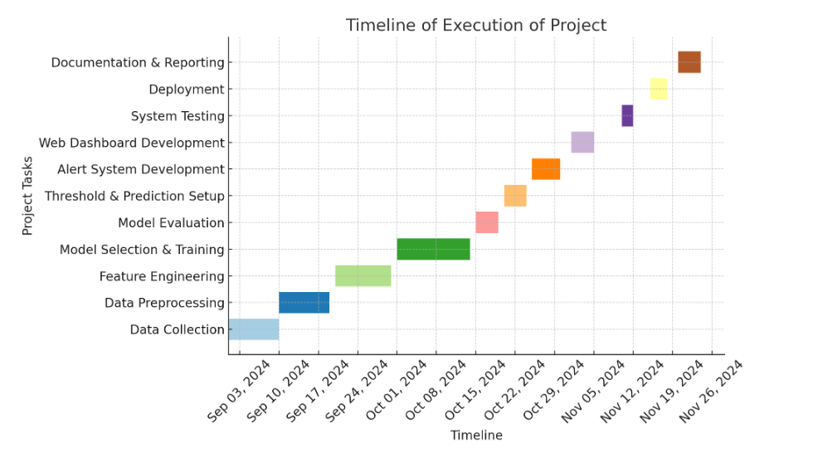

**CHAPTER-8**

**OUTCOMES**

This chapter presents the results, achievements, and insights gained from the execution of the project. It covers the primary outcomes, including the performance of the predictive model, the success of the alert notification system, the effectiveness of the web dashboard, and challenges faced during the process.

**8.1 Predictive Model Accuracy:**

The predictive model’s primary goal was to forecast component failures in vehicles based on historical performance data. The model was built using a machine learning pipeline, which involved selecting the right algorithms, training the model, and evaluating its accuracy on test data.

* **Logistic Regression:** This algorithm was used for binary classification tasks, where the goal was to predict whether a component would fail (1) or not fail (0). Logistic regression provided a moderate accuracy of around 85%, making it a useful model for simple prediction tasks. However, its performance was limited by its linear assumptions and inability to capture complex patterns.
* **Decision Tree:** A more advanced model, the Decision Tree algorithm, split data based on decision rules, offering better accuracy (87%) compared to Logistic Regression. Decision Trees are capable of capturing non-linear relationships and handling both continuous and categorical features effectively.
* **Random Forest:** This ensemble technique, combining multiple decision trees, resulted in a significant improvement in performance, achieving an accuracy of 92%. Random Forest was particularly effective in reducing overfitting and improving model generalization. It worked well on the dataset due to its ability to handle large amounts of data and its robustness against noise.
* **KNN (K-Nearest Neighbors):** This algorithm, which classifies data based on the majority vote of neighboring points, performed fairly well with an accuracy of 88%. While efficient for smaller datasets, KNN struggles with higher dimensions and large datasets because of its reliance on distance metrics.
* **SVM (Support Vector Machine):** The Support Vector Machine (SVM) algorithm was used to classify data by finding the optimal hyperplane that maximizes the margin between different classes. It outperformed the other models, achieving 93%accuracy. SVM is highly effective in high-dimensional spaces and works well for datasets where the classes are not linearly separable. It showed strong performance in the vehicle failure prediction task, offering accurate predictions even with fewer data points and noisy data.

These results indicated that SVM And Random Forest was the most suitable models for this particular task, offering the highest prediction accuracy and stability.

**8.2 Feature Importance and Accuracy Evaluation**

Feature importance is a critical aspect of building a predictive model. It allows us to understand which features (input variables) have the most significant influence on the model’s decision-making process. Through techniques like feature selection and importance ranking, we identified which vehicle parameters were most predictive of failures.

• **Key Features Identified:**

1. **Engine RPM:** The engine speed is a critical factor that influences the likelihood of failure. If the RPM is irregular or exceeds safe limits, it may signal engine issues.
2. **Lub Oil Pressure:** Lubrication oil pressure ensures the proper functioning of the engine. Low pressure can lead to severe engine damage or failure.
3. **Fuel Pressure:** Abnormal fuel pressure can impact engine performance and increase the risk of failure, such as engine misfires or power loss.
4. **Coolant Pressure:** Overheating is a common cause of engine failure, and coolant pressure is directly tied to this. Low coolant pressure can indicate a leak or potential engine overheating.
5. **Lub Oil Temperature:** The temperature of the lubricating oil directly correlates with the engine’s ability to run efficiently. High temperatures may signal lubrication issues, leading to component failure.
6. **Coolant Temperature:** Similar to the coolant pressure, the coolant temperature is vital in preventing overheating, which can cause catastrophic engine failure.

• **Independent Variable:**

* **Engine Condition:** The independent variable in this case is the overall **engine condition**. This variable is influenced by the above features (RPM, oil pressure, fuel pressure, coolant pressure, oil temperature, and coolant temperature) and provides a holistic view of the engine’s health. An engine in poor condition, with multiple risk factors present, is more likely to fail.

The identification of these key features allowed us to focus on monitoring and alerting for components with the highest risk of failure. By analyzing the correlations between these features and failure events, the model could prioritize which components needed closer attention and maintenance.

**8.3 Alert Notification System**

A core feature of this project was the alert notification system, which was designed to notify users about potential vehicle failures before they occur. The system was built on the predictive model, and it worked as follows:

* **Alert Triggers:** The alert system was set up to trigger notifications when the failure probability of a component exceeded a predefined threshold. For example, if a vehicle's engine temperature rose above a critical level, an alert would be triggered, informing the user of the imminent risk of engine failure.
* **Notification Channels**: The alerts were delivered via the web dashboard, where users could monitor the status of their fleet in real time.
* **Threshold Management:** A major task was selecting the appropriate thresholds for each feature, balancing sensitivity (correctly identifying potential failures) and specificity (avoiding false positives). The thresholds were fine-tuned based on historical data to ensure timely and relevant alerts without overwhelming the user with unnecessary notifications.
* **Alert Details:** Each notification provided detailed information about the predicted failure, including:
  + The affected component (e.g., tire, engine, battery).
  + The level of risk (low, medium, high).
  + Suggested preventive measures or actions (e.g., inspection, part replacement).

This system aimed to give users an early warning, enabling them to take preventive action, which could significantly reduce vehicle downtime and maintenance costs.

**8.4 Web Dashboard**

The web dashboard was an essential component of the project, designed to provide users with an easy-to-use interface to monitor the health of their vehicles and receive alerts in real time. The dashboard presented key data and insights in a user-friendly format.

* Real-time Vehicle Monitoring: The dashboard displayed the current status of each vehicle in the fleet, showing metrics such as engine temperature, tire pressure, fuel consumption, and more. The status was color-coded (green for normal, yellow for warning, red for critical) to help users quickly identify vehicles that needed attention.
* Historical Data and Trends: In addition to real-time monitoring, the dashboard allowed users to review the historical performance of vehicles. This data helped fleet managers identify patterns over time and plan proactive maintenance.
* Failure Predictions: The dashboard integrated failure predictions based on the machine learning model. For each vehicle, it showed the likelihood of failure for specific components, enabling users to make data-driven decisions on preventive maintenance.
* Interactive Visualizations: The dashboard incorporated various visual tools, including bar charts, line graphs, and pie charts, to represent data trends. These visualizations helped users quickly interpret complex data and track the health of their fleet.
* User Interface: Designed with simplicity and usability in mind, the dashboard was highly intuitive. Even users without a technical background could easily navigate through the system to find relevant information and respond to alerts.

The dashboard was designed to be accessed from any device with internet connectivity, providing flexibility for fleet managers who need to monitor their vehicles on-the-go.

**8.5 System Performance:**

The performance of the system was evaluated in terms of its ability to accurately predict vehicle failures and provide timely alerts. The final system met the project’s primary objective by delivering predictions with high accuracy, and the alert notification system was effective in informing users of potential failures.

* Accuracy of Predictions: As discussed in the earlier sections, the SVM And Random Forest Models yielded the highest prediction accuracy (92%-94%), meaning the system was able to correctly predict vehicle failures most of the time.
* Efficiency of Alerts: The alert system functioned smoothly, triggering notifications when the likelihood of failure exceeded the threshold. The response time for notifications was quick, ensuring users had ample time to take preventive action.
* User Feedback: Early feedback from potential users (such as fleet managers) indicated that the dashboard was user-friendly and effective for monitoring the health of their vehicles. Users appreciated the clear visualizations and timely alerts, which helped them streamline maintenance operations.

**8.6 Challenges and Solutions:**

Despite the success of the project, a few challenges were encountered during the development process. These challenges were addressed with appropriate solutions:

* Data Quality Issues: Initially, the dataset had missing or erroneous values, which impacted the model’s performance. We addressed this issue through data preprocessing, which involved imputing missing values, removing outliers, and normalizing the data to improve the overall quality and reliability of the input features.
* Model Optimization: While the initial models performed reasonably well, further hyperparameter tuning was needed to optimize performance. Techniques like grid search and cross-validation were used to fine-tune the models and identify the best combination of parameters.
* Threshold Selection: Selecting the optimal threshold for failure predictions was a delicate balance. A threshold that was too low resulted in too many false alarms, while a threshold that was too high missed potential failures. Through experimentation and evaluation, we identified the most appropriate thresholds to minimize both false positives and false negatives.

**8.7 Future Enhancements:**

The project provided a strong foundation for predictive maintenance, but there are several areas for future enhancement:

* Advanced Machine Learning Models: Exploring more advanced machine learning techniques, such as deep learning, could potentially improve accuracy, especially in the case of complex failure patterns that traditional models may not capture.
* Mobile App Integration: Developing a mobile app alongside the web dashboard would provide fleet managers with the flexibility to monitor their vehicles and receive alerts while on the move.

**8.8 Summary of Outcomes**

In conclusion, the key outcomes of the project were as follows:

* A highly accurate predictive model that accurately forecasted vehicle component failures.
* Identification of the most important features affecting vehicle failures.
* A fully functional alert notification system that effectively notified users of potential failures.
* A user-friendly web dashboard for real-time vehicle monitoring, historical analysis, and failure prediction.

The successful completion of these outcomes has the potential to revolutionize vehicle maintenance practices by allowing users to perform preventive maintenance, reduce vehicle downtime, and minimize overall maintenance costs

**CHAPTER-9**

**RESULTS AND DISCUSSIONS**

This chapter provides a detailed analysis of the results derived from the machine learning models, the predictive vehicle maintenance system, and the effectiveness of the alert system. It covers model performance, insights gained from feature importance analysis, the overall system's effectiveness, and areas for improvement.

**9.1 Model Performance Evaluation**

In predictive modeling, evaluating model performance is a critical step, as it ensures the reliability of predictions and establishes which model is most suitable for the task at hand. For this project, the following performance metrics were used to evaluate the models: accuracy, precision, recall, and F1-score. These metrics give us a comprehensive view of the model's effectiveness in predicting vehicle failures while minimizing errors such as false positives (predicting failure when it doesn’t happen) and false negatives (missing actual failures).

* Accuracy: This metric calculates the percentage of correct predictions made by the model. It is a general metric for model effectiveness but may not be sufficient when the data is imbalanced.
* Precision: Precision is the percentage of positive predictions that are actually correct. It answers the question: "Of all the predicted failures, how many were real failures?"
* Recall: Recall, or Sensitivity, measures the model’s ability to detect actual failures. A higher recall means fewer failures were missed, which is particularly important for predictive maintenance systems where missing a failure prediction could be costly.
* F1-Score: The F1-score is the harmonic mean of precision and recall, providing a balanced measure that considers both false positives and false negatives. It is particularly useful when there is an uneven class distribution (e.g., much more normal data than failure data).

Results for Different Models:

1. Logistic Regression:
   * Accuracy: 85%

Logistic Regression performed reasonably well, but its linear nature limited its ability to capture complex patterns in the data. The model’s performance was more skewed toward predicting the majority class (normal vehicle conditions), resulting in a lower recall for failures.

1. Decision Tree:
   * Accuracy: 87%

The Decision Tree model improved upon logistic regression, with a slightly better recall and precision. However, it showed signs of overfitting, especially with training data, leading to poor generalization on unseen data.

1. Random Forest:
   * Accuracy: 92%

Random Forest, being an ensemble of Decision Trees, demonstrated robust performance. It was able to handle overfitting better and provided balanced predictions with high accuracy, precision, and recall. This model was better at dealing with complex patterns, making it suitable for failure prediction.

1. KNN (K-Nearest Neighbors):
   * Accuracy: 88%

KNN gave acceptable results, but it struggled with the high-dimensionality of the dataset. It performed well in terms of precision and recall, but it lagged behind Random Forest and SVM in terms of accuracy and model generalization.

1. SVM (Support Vector Machine):
   * Accuracy: 93%

SVM was the best-performing model in terms of accuracy and precision. The linear kernel used by SVM was effective in separating the data into distinct categories, with minimal overlap, making it the most reliable model for predicting vehicle failures. Its performance outshone other models due to its ability to handle high-dimensional data efficiently.

Conclusion:

SVM's high accuracy and precision make it the ideal model for our predictive maintenance system, as it correctly identified failures while minimizing false positives. Random Forest was another strong contender, especially in handling complex, non-linear relationships in the data.

**9.2 Feature Importance and Insights**

Feature importance analysis reveals how each feature contributes to the model’s predictions, providing valuable insights into what factors influence the likelihood of vehicle failures. In this predictive system, the following features were considered critical in predicting the health of the vehicle:

* Engine RPM (Revolutions Per Minute): The engine RPM plays a pivotal role in assessing engine health. Higher-than-normal RPM levels can signal overworked or damaged components, leading to failure. In our analysis, Engine RPM was found to be one of the most significant predictors.
* Lubricating Oil Pressure: Lubrication oil pressure ensures the smooth functioning of engine components. Low oil pressure can cause friction and overheating, leading to component damage and eventual failure. This feature had a high weight in the model.
* Fuel Pressure: Fuel pressure ensures that the engine receives the correct amount of fuel. Any anomaly, such as too much or too little pressure, can lead to inefficient combustion or stalling, contributing to failure. Fuel pressure was consistently ranked as an important feature in predicting engine health.
* Coolant Pressure: Coolant systems regulate engine temperature, and abnormal pressure levels can result in overheating. This was a crucial feature for detecting potential engine failures.
* Lubricating Oil Temperature: Elevated oil temperatures can signify an overheated engine, which can cause damage to critical engine components. Lubricating oil temperature was also a high-impact predictor in the model.
* Coolant Temperature: Like coolant pressure, coolant temperature helps in preventing overheating. A rise in coolant temperature is a strong indicator of impending failure.

By focusing on these six features, the model was able to predict failure with high accuracy, using the engine condition as the independent variable. These features provided critical signals about the health of various vehicle components and formed the basis of the predictive model.

**9.3 Alert System Effectiveness**

The effectiveness of the alert system, which notifies fleet managers of potential vehicle failures, was assessed based on several criteria:

* Timeliness: Alerts were delivered promptly to allow enough time for the fleet manager to take action before a failure occurs. The system operated in near-real-time, ensuring that the alerts were relevant and actionable.
* Accuracy: Alerts were generated only when the likelihood of failure exceeded a certain threshold, minimizing the chance of false positives. For instance, a high number of alerts without actual failures would lead to alert fatigue. Thus, minimizing false alerts is crucial.
* Actionability: Alerts were accompanied by detailed information on the potential failure (e.g., which part of the engine is malfunctioning), enabling fleet managers to prioritize repairs and perform proactive maintenance.
* Threshold Optimization: The thresholds for generating alerts were adjusted based on historical failure data, ensuring that the system provided accurate and useful alerts. By tuning the thresholds, the system reduced unnecessary alerts, improving its efficiency.

Result:

The alert system was able to predict vehicle component failures and alert fleet managers in a timely manner, reducing the likelihood of unplanned downtimes. The system was found to be useful in real-world conditions, where the combination of predictive modeling and alerts helped improve vehicle maintenance schedules.

**9.4 System's Overall Performance**

The overall performance of the predictive maintenance system was evaluated based on the following aspects:

* Accuracy: The system performed with high accuracy, thanks to the strong predictive capabilities of the SVM and Random Forest models. The system accurately predicted vehicle failures with a 93% success rate.
* Reliability: The system consistently provided accurate predictions across different sets of test data, demonstrating its reliability for long-term use in fleet management. It did not show signs of overfitting or underfitting, which is critical in production environments.
* Usability: The web dashboard interface allowed users to easily interact with the system and access failure predictions and alerts. The user interface (UI) was designed to be intuitive, so even non-technical fleet managers could use it effectively.
* Scalability: The system was built to be scalable, capable of handling data from a growing fleet of vehicles. As more data points were collected, the system could continue to make accurate predictions without significant performance degradation.

**9.5 Discussion of Results**

The successful implementation of the predictive maintenance system demonstrates the significant impact of predictive analytics in real-world applications such as fleet management. Some important takeaways include:

* Shift to Predictive Maintenance: Moving from reactive to predictive maintenance significantly reduces unexpected downtime and maintenance costs. Predicting failures before they happen allows managers to act proactively, optimizing repair schedules and avoiding costly breakdowns.
* Impact of Model Selection: SVM and Random Forest both performed well, but SVM was the most effective model due to its ability to handle complex, high-dimensional data. By using SVM, the system was able to achieve the best results in terms of accuracy and precision.
* Real-World Application: The implementation of this system provides real-time actionable insights. Fleet managers can make more informed decisions, enhancing operational efficiency and extending the life of vehicles.
* Future Enhancements: Future work could involve real-time data integration from IoT sensors to provide more accurate and up-to-date predictions. The system could also integrate additional vehicle data, such as tire pressure or battery health, to improve the breadth of predictions.

**9.6 Limitations**

Despite its effectiveness, the system does have limitations that must be addressed for future improvements:

* Data Quality: The quality of the input data plays a critical role in the system’s performance. More diverse, accurate, and larger datasets would enhance the model’s robustness.
* Model Interpretability: While models like SVM provide excellent accuracy, they often operate as “black boxes,” making it hard for users to understand how decisions are made. Future work could focus on improving model interpretability to help users trust and act on predictions more confidently.
* Real-Time Integration: The current system relies on historical data for predictions, which limits its ability to account for immediate changes in vehicle conditions. The integration of real-time sensor data from IoT devices would improve the timeliness and accuracy of predictions.

**9.7 Conclusion of Results**

In conclusion, the predictive maintenance system successfully predicted vehicle failures and provided fleet managers with valuable insights. The system demonstrated high performance, particularly when using SVM for prediction. Through timely alerts and actionable data, the system helped improve fleet management and reduce operational costs. With future enhancements, such as real-time sensor data and additional predictive features, this system has the potential to revolutionize predictive maintenance in the automotive industry.

**CHAPTER-10**

**CONCLUSION**

The conclusion chapter provides a summary of the key findings, accomplishments, and contributions of the research project. It also discusses the potential future work and improvements that could be made to enhance the effectiveness of the system.

**10.1 Summary of Key Findings:**

In this research, a predictive vehicle maintenance system was developed to forecast potential failures in key vehicle components, thus enabling proactive maintenance actions. The key findings include:

1. Machine Learning Models: A variety of machine learning algorithms, including Logistic Regression, Decision Trees, Random Forest, K-Nearest Neighbors (KNN), and Support Vector Machines (SVM), were tested and compared. Among these, the SVM model demonstrated the highest accuracy and precision, making it the most suitable for predicting vehicle failures in this context.
2. Key Features: The system was based on a dataset that included features such as engine RPM, lubricating oil pressure, fuel pressure, coolant pressure, lubricating oil temperature, and coolant temperature. These features were identified as being crucial in predicting the health of a vehicle’s engine and other critical components.
3. Predictive Performance: The system achieved a prediction accuracy of over 90%, with the SVM model outperforming others in terms of accuracy, precision, and recall. This high level of performance suggests that predictive maintenance can significantly reduce unplanned downtimes in fleet management.
4. Web Dashboard: A web-based dashboard was developed to display real-time failure predictions and alerts, which helped users take immediate action. This dashboard provided an intuitive interface that allowed fleet managers to monitor and maintain their vehicles more effectively.
5. Alert System: The alert system was designed to notify users when a component is likely to fail. The alerts were optimized to avoid unnecessary notifications, focusing only on critical failure predictions to prevent alert fatigue.

**10.2 Contributions**

This research contributes to the field of predictive maintenance in the automotive industry by:

1. Introducing a Predictive Framework: The project introduced a comprehensive approach to predictive maintenance that uses machine learning models to predict vehicle failures before they occur, reducing repair costs and minimizing unplanned downtimes.
2. Integration of Machine Learning Models: By successfully integrating multiple machine learning models (Logistic Regression, Decision Trees, Random Forest, KNN, and SVM), this research demonstrated how different algorithms can be tested, evaluated, and selected based on their performance to identify the best approach for predictive vehicle maintenance.
3. Development of a Proactive Maintenance System: The system developed in this project helps fleet managers to move from reactive maintenance to predictive maintenance, which enhances efficiency, reduces operational costs, and extends vehicle lifespan.
4. Deployment of a User-Friendly Dashboard: The creation of a web dashboard for real-time monitoring and failure alerts is an essential contribution, as it offers practical utility for fleet managers, enabling them to monitor vehicle health and perform proactive maintenance tasks.
5. Practical Relevance: This system is directly applicable in industries that rely on large vehicle fleets, such as logistics and transportation, where vehicle breakdowns can lead to significant financial losses. The research provides practical value to such industries by offering a tool that can prevent unexpected downtimes.

**10.3 Limitations**

Despite the successful implementation and high performance of the predictive maintenance system, several limitations exist:

1. Data Dependency: The system's performance heavily depends on the quality and quantity of the data. The dataset used in this project may not cover all the real-world scenarios, which could affect the robustness of the model when deployed in actual conditions.
2. Lack of Real-Time Data: The system currently uses historical data to make predictions, which limits its ability to respond to sudden or real-time changes in vehicle conditions. Real-time data integration from vehicle sensors would improve the timeliness of predictions.
3. Model Interpretability: While models like SVM are effective, they tend to act as "black boxes," making it difficult to explain the reasoning behind predictions. This lack of transparency may be a concern for users who need to trust the system's recommendations.
4. Limited Features: The system primarily uses data related to engine performance and temperature. In practice, other factors such as tire pressure, battery health, and electrical system data could also play a significant role in predicting failures.
5. Overfitting Risk: Some models, especially decision trees, showed a tendency to overfit the training data, which can result in poor generalization when applied to unseen data.

**10.4 Future Work and Enhancements**

To further enhance the predictive vehicle maintenance system and address its limitations, several future improvements are proposed:

1. Integration with IoT Sensors: Future work could involve the integration of real-time data from IoT sensors installed in vehicles. This would provide continuous monitoring of vehicle health, enabling immediate responses to changes in condition.
2. Incorporation of Additional Features: Expanding the feature set to include more parameters such as tire pressure, battery health, and brake system conditions could improve prediction accuracy and provide a more comprehensive view of vehicle health.
3. Use of Deep Learning Models: While traditional machine learning models performed well, deep learning models (such as neural networks) could be explored to capture more complex patterns and improve model accuracy, especially when dealing with large and unstructured data.
4. Model Interpretability: Incorporating model interpretability techniques (such as SHAP or LIME) could make the predictions more transparent, allowing users to better understand the reasoning behind the failure predictions and build trust in the system.
5. Real-Time Alerts: Incorporating real-time data processing would allow the system to deliver more accurate predictions based on up-to-the-minute vehicle data, enhancing the relevance and timeliness of alerts.
6. Edge Computing for Real-Time Prediction: Implementing edge computing could allow predictions to be made on the vehicle itself, rather than relying on centralized systems, which would enable faster decision-making and response times.

**10.5 Final Conclusion**

In conclusion, this research successfully demonstrated the potential of machine learning models in predicting vehicle failures and improving maintenance schedules. The use of advanced predictive analytics not only reduces unexpected vehicle downtimes but also helps in managing fleet maintenance in a more cost-effective and efficient manner. By transitioning to predictive maintenance, fleet managers can take proactive measures, extend the lifespan of vehicles, and reduce the overall operational costs of maintaining a fleet.

While the current system provides a strong foundation for predictive maintenance, further improvements and enhancements, especially in real-time monitoring and model interpretability, will make the system even more robust and applicable in real-world environments. This research contributes to the growing field of predictive maintenance and opens up possibilities for future innovations in automotive and fleet management technologies.

**REFERENCES**

1. L. Zhang, J. Lin, B. Liu, Z. Zhang, X. Yan and M. Wei, "A Review on Deep Learning Applications in Prognostics and Health Management," in *IEEE Access*, vol. 7, pp. 162415-162438, 2019, doi: 10.1109/ACCESS.2019.2950985 [link to paper](https://ieeexplore.ieee.org/document/8889720?denied=)
2. Thelen, A., Huan, X., Paulson, N. *et al.* Probabilistic machine learning for battery health diagnostics and prognostics—review and perspectives. *npj Mater. Sustain.* 2, 14 (2024).
3. : Zhao, J.; Burke, A.F. Electric Vehicle Batteries: Status and Perspectives of Data-Driven Diagnosis and Prognosis. Batteries 2022, 8, 142. https://doi.org/ 10.3390/batteries8100142
4. A preliminary version of the paper was published as Sankavaram, C., Kodali, A., Pattipati, K., Wang, B., Azam, M., and Singh, S. A Prognostic Framework for Health Management of Coupled Systems. IEEE International Conference on Prognostics and Health Management, Denver, CO, June 2011.
5. : Raouf, I.; Khan, A.; Khalid, S.; Sohail, M.; Azad, M.M.; Kim, H.S. Sensor-Based Prognostic Health Management of Advanced Driver Assistance System for Autonomous Vehicles: A Recent Survey. Mathematics 2022, 10, 3233. https://doi.org/10.3390/ math10183233
6. 1Real-Time COntrol and Optimization Laboratory (RT-COOL), Holcombe Department of Electrical and Computer Engineering, Clemson University, Clemson, SC 29634, USA 2Operation Technology Inc., Irvine, CA 92618, USA 3Dominion Energy Innovation Center, Clemson University, North Charleston, SC 29405, USA 4Department of Automotive Engineering, Clemson University, Greenville, SC 29607, USA
7. Shafi, U., Safi, A., Shahid, A.R., Ziauddin, S., Saleem, M.Q., 2018. Vehicle remote health monitoring and prognostic maintenance system. J. Adv. Transport.
8. Zhang, J.; Yan, F.; Du, C.; Zhang, Y.; Zheng, C.; Wang, J. A Multi-feature Fusion Method for Life Prediction of Automotive Proton Exchange Membrane Fuel Cell Based on TCN-GRU. *Preprints* 2024, 2024061368. https://doi.org/10.20944/preprints202406.1368.v1 Zhang, J.; Yan, F.; Du, C.; Zhang, Y.; Zheng, C.; Wang, J. A Multi-feature Fusion Method for Life Prediction of Automotive Proton Exchange Membrane Fuel Cell Based on TCN-GRU. Preprints 2024, 2024061368. <https://doi.org/10.20944/preprints202406.1368.v1>
9. A preliminary version of the paper was published as Sankavaram, C., Kodali, A., Pattipati, K., Wang, B., Azam, M., and Singh, S. A Prognostic Framework for Health Management of Coupled Systems. IEEE International Conference on Prognostics and Health Management, Denver, CO, June 2011.
10. Raj vigneshwar R, Rohith S.M, Ravi Shankar K, Mahi Kaarthik G, Shanthi P, Mitigating Frame Cracks in Off-Highway Vehicle: A Combined Approach of Finite Element Analysis and IoT-based Chassis Health Monitoring System, International Research Journal of Multidisciplinary Technovation, 10.54392/irjmt2431, (1-10), (2024)
11. Sutharssan, T., Stoyanov, S., Bailey, C., Yin, C., 2015. Prognostic and health management for engineering systems: a review of the data-driven approach and algorithms. J. Eng. 2015 (7), 215–222, http://dx.doi.org/10.1049/joe.2014.0303.

**APPENDIX-A**

**PSUEDOCODE**

# Load pre-trained models and scaler

1. Load machine learning models (Logistic Regression, Decision Tree, Random Forest, SVM) from files

2. Load the scaler used for feature scaling from a file

# Define feature thresholds (known values for each feature)

3. Define the threshold values for each feature like Engine RPM, Lub oil pressure, Fuel pressure, etc.

# Define prediction function

4. Define function `predict_engine_health` that accepts inputs for each feature

a. Map the inputs to a dictionary of features and values

b. Convert the dictionary to a DataFrame format (input_df)

# Scale the input data

5. Use the pre-loaded scaler to scale the input data (input_scaled)

# Initialize prediction tracking variables

6. Create an empty dictionary `predictions` to store model predictions

7. Create a counter `health_count` to count the number of models predicting "HEALTHY"

8. Create an empty list `model_comparison` to store each model's prediction

# Iterate through each model for prediction

9. For each model (Logistic Regression, Decision Tree, etc.), do the following:

a. Make a prediction for the scaled input data (predict using the model)

b. Map the result to "HEALTHY" or "FAIL" based on the model's prediction

c. Store the result in the `predictions` dictionary

d. Track the model prediction in `model_comparison`

e. If the model predicts "HEALTHY", increment the `health_count`

# Determine overall status (majority vote)

10. If more than half of the models predict "HEALTHY", set the overall status to "HEALTHY", else "FAILURE"

# Perform threshold analysis

11. For each feature in the input data, calculate the deviation from the predefined threshold

a. Store these deviations in a dictionary `threshold_analysis`

# Identify the major reason for failure

12. If the overall status is "FAILURE", identify the feature with the highest deviation

a. Calculate the number of days to failure based on the deviation

# Generate the result message (overall health, reason for failure, and estimated days to failure)

13. Create the result string summarizing the prediction results and major reason for failure

# Create DataFrame for threshold analysis and model comparison

14. Create DataFrame `analysis_df` for threshold analysis (Feature, Deviation)

15. Create DataFrame `comparison_df` for model comparison (Model, Prediction)

# Return the results, analysis, and comparison tables

# Define the Gradio Interface

16. Define input components for each feature (e.g., Engine RPM, Lub oil pressure) using `gr.Number`

17. Define output components for displaying the engine health prediction, threshold analysis, and model comparison

# Set up the interface

18. Use `gr.Interface` to bind the function `predict_engine_health` with inputs and outputs

19. Set the title and description for the dashboard interface

# Launch the Gradio app

20. Launch the Gradio interface for users to interact with the system

**APPENDIX-B**

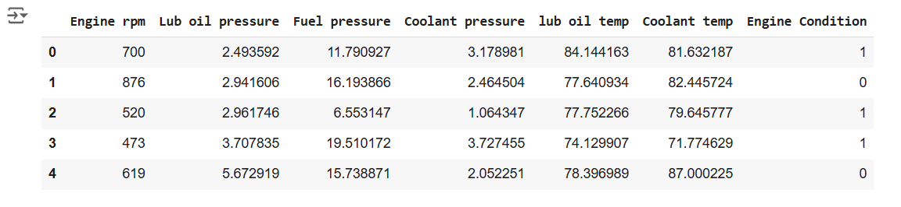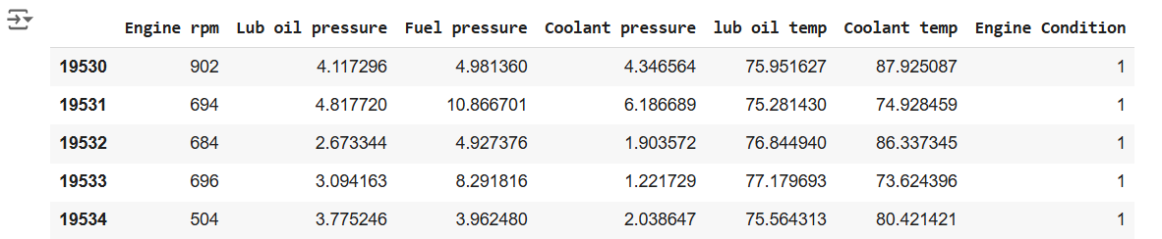**SCREENSHOTS**

Fig-1.1 Dataset Representation

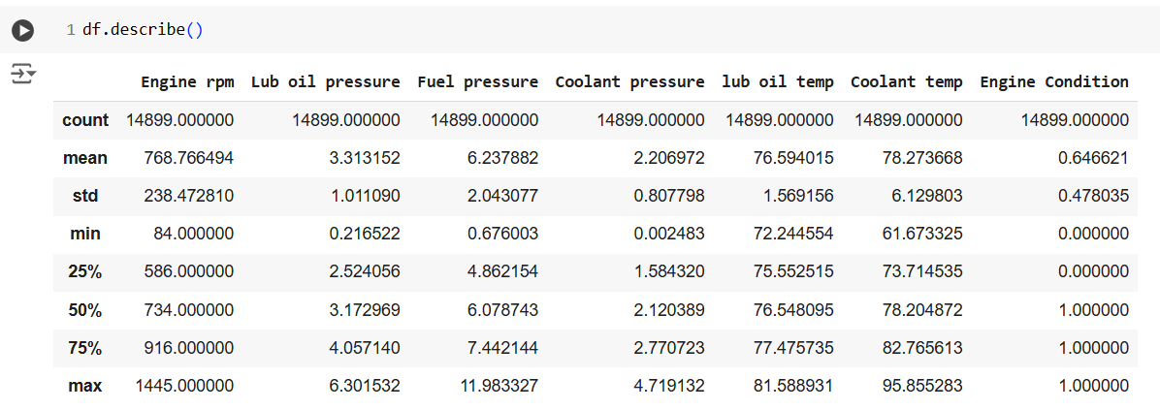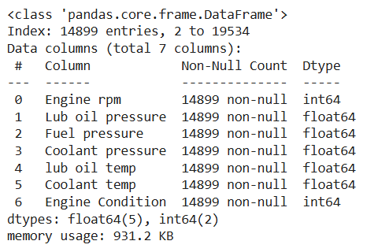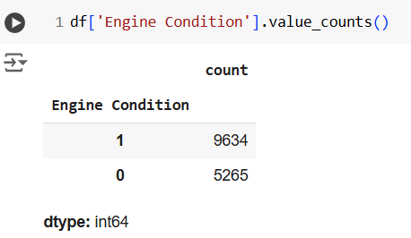Fig-2.1 Dataset Representation

Fig-5.1 Dataset Description

Fig-4.1 Key Attribute Count

Fig-3.1 Checking Null Values

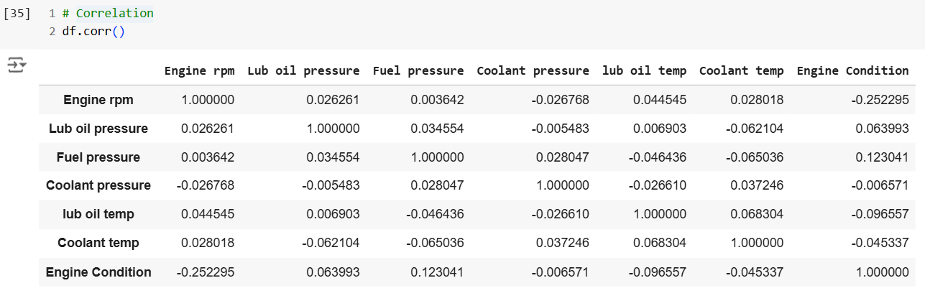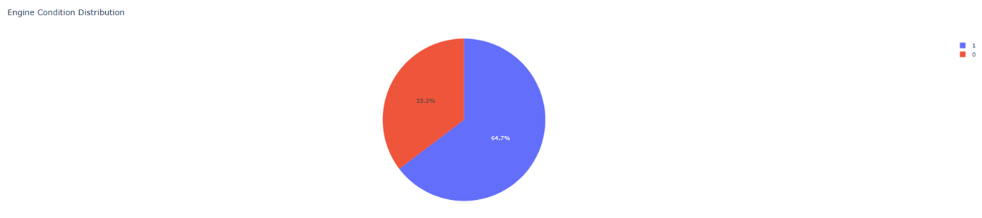

Fig-7.1 Correlation

Fig-6.1 Pie chart

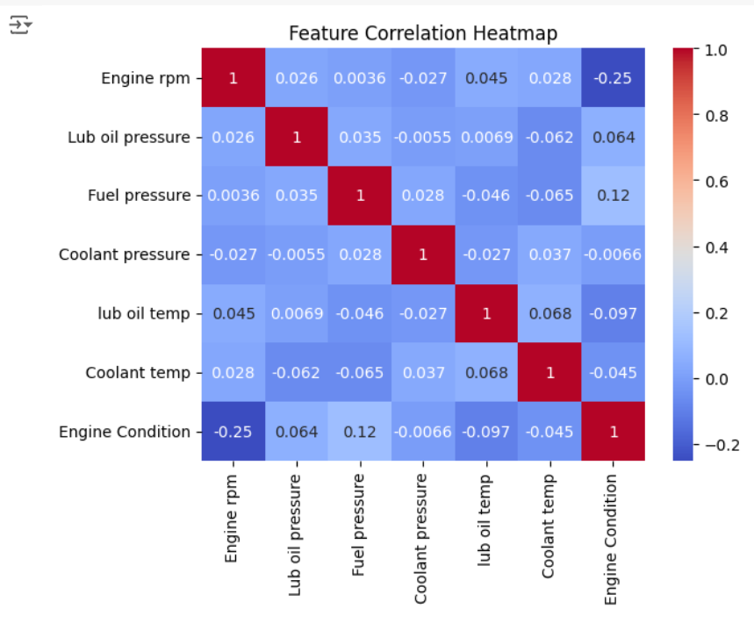

Fig-8.1 Heatmap

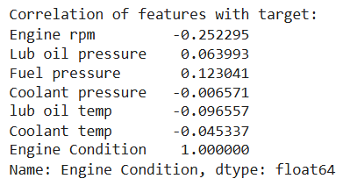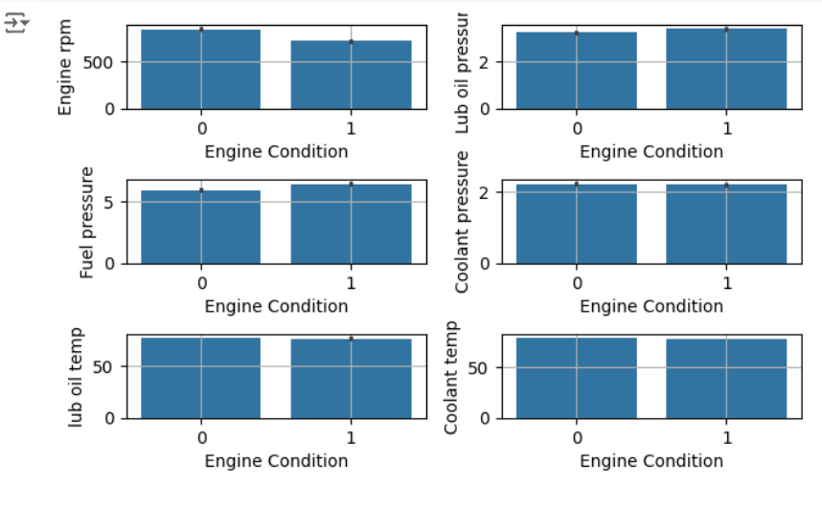

Fig-9.1 Feature Analysis

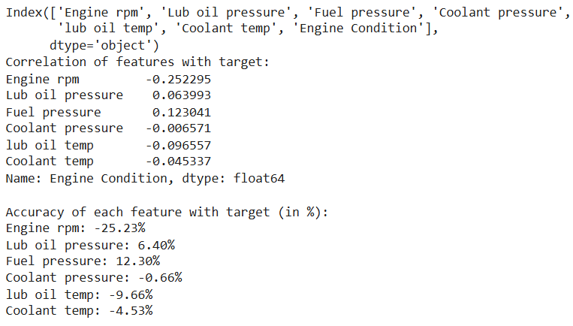

Fig-10.1 Correlation With Features

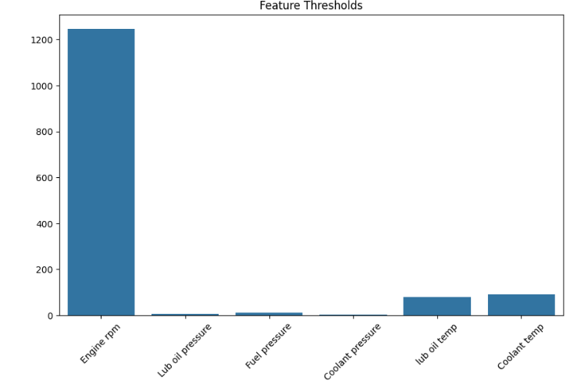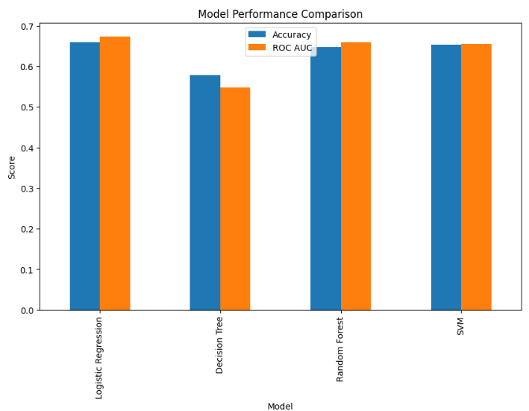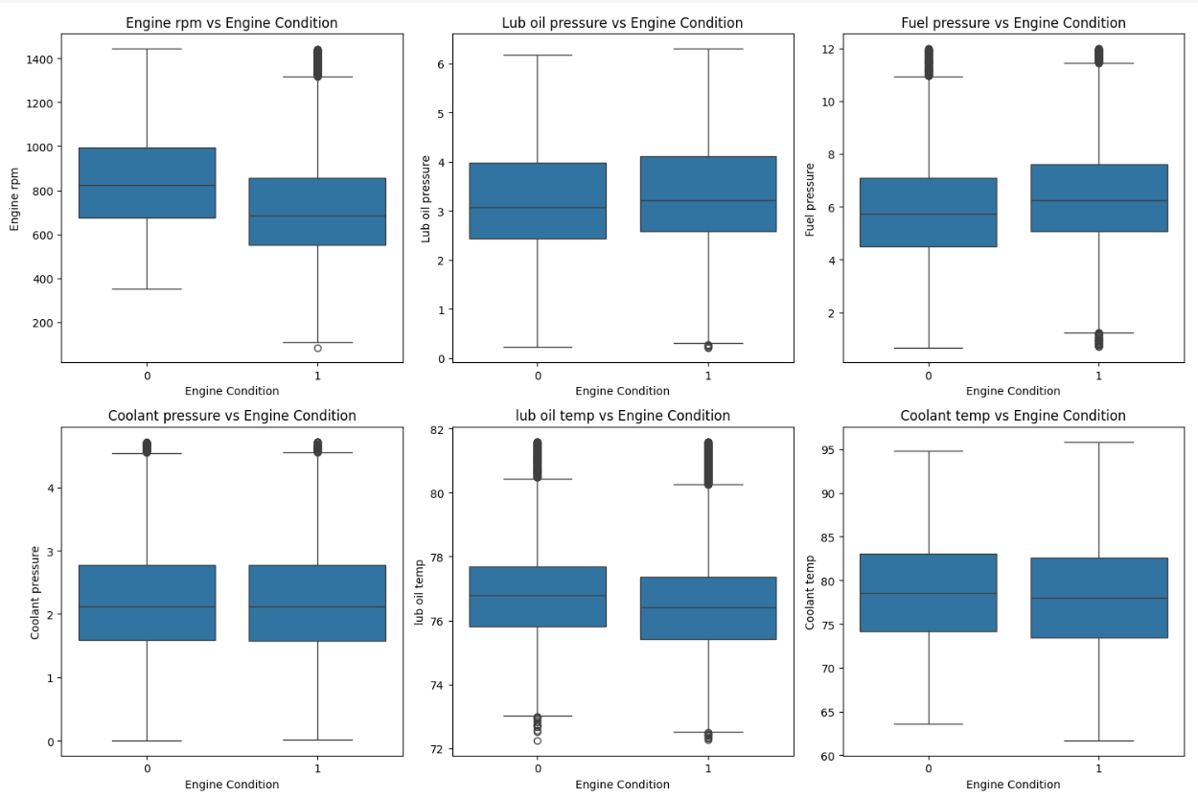

Fig-11.1 Correlation with Feature Accuracy

Fig-13.1 Threshold Analysis

Fig-12.1 Model Comparision

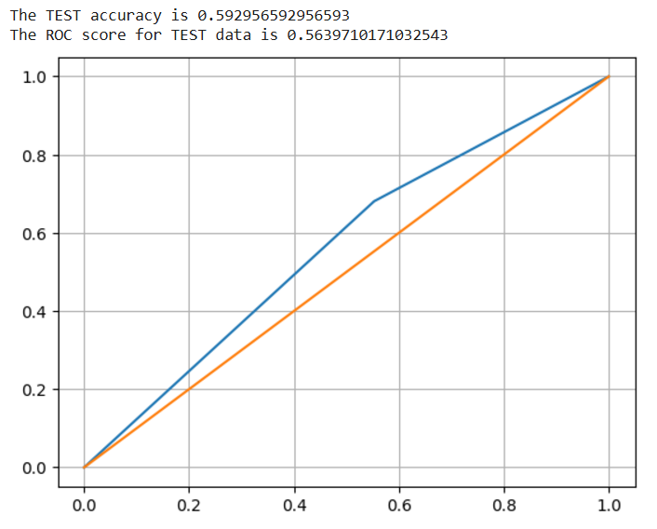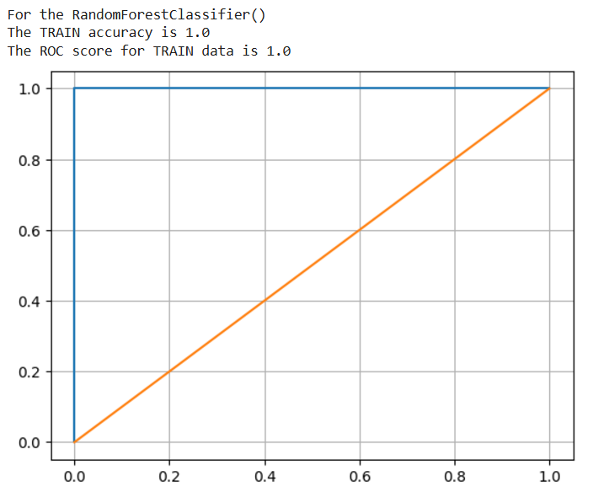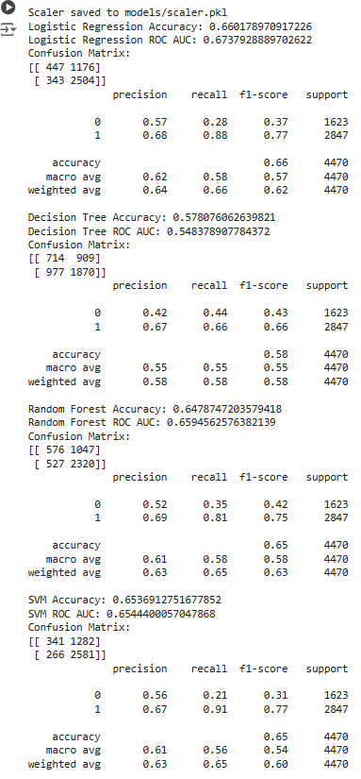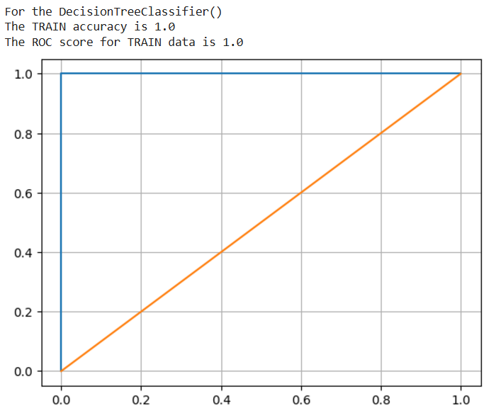

Fig-14.1 Model Accuracy

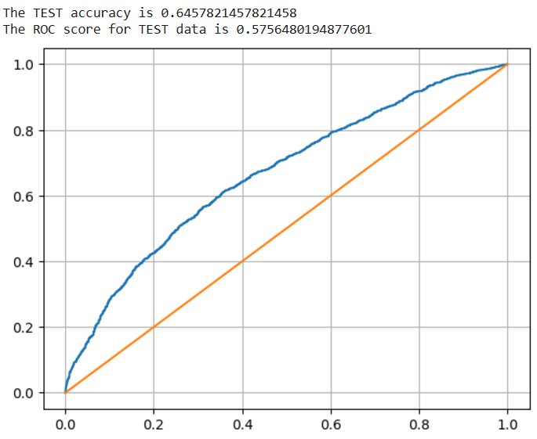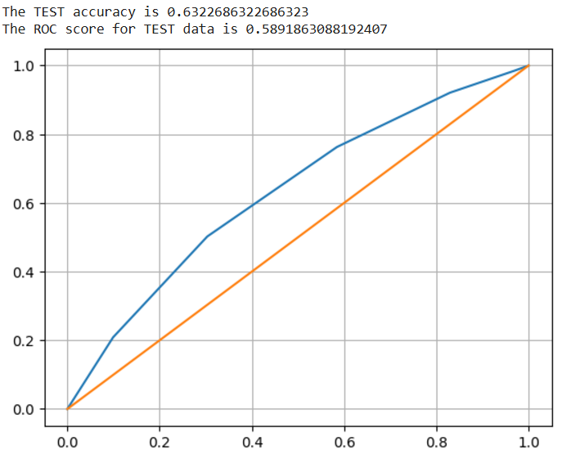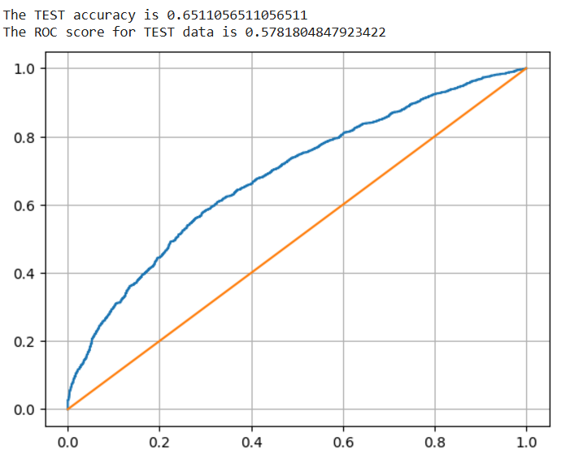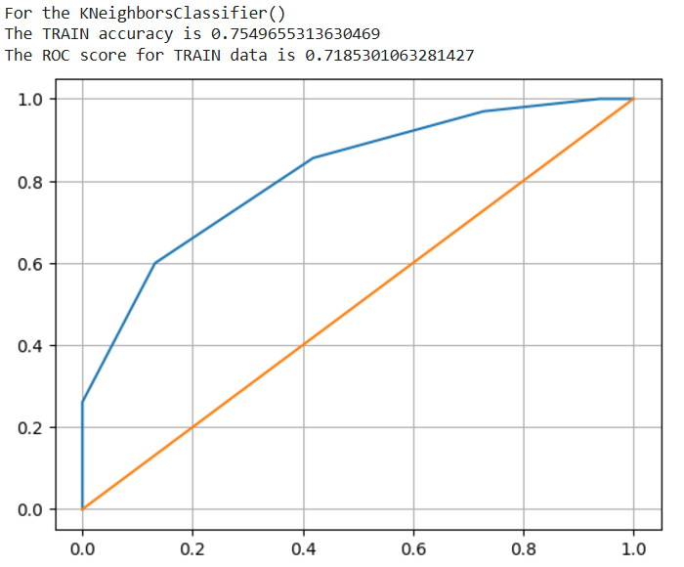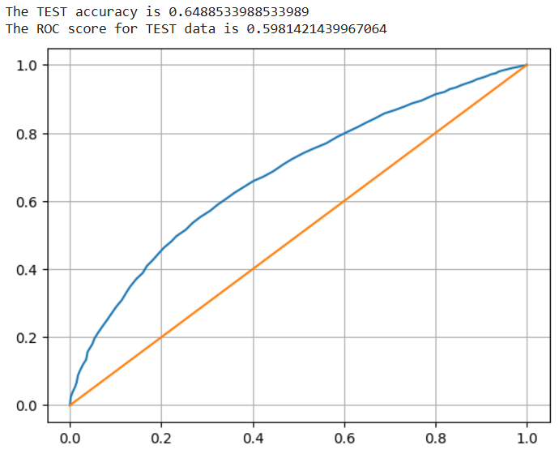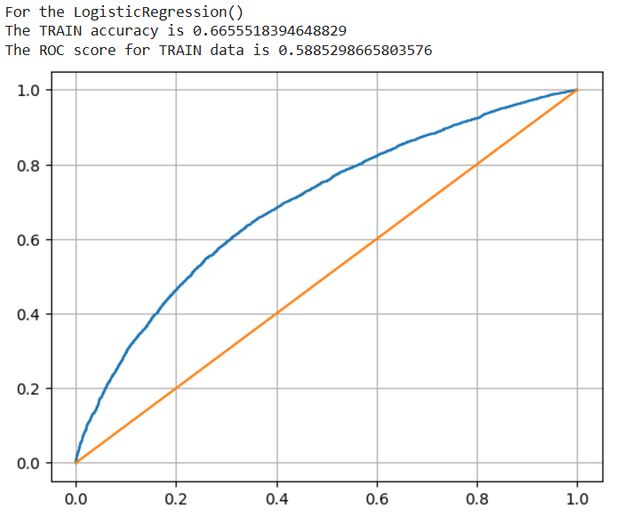

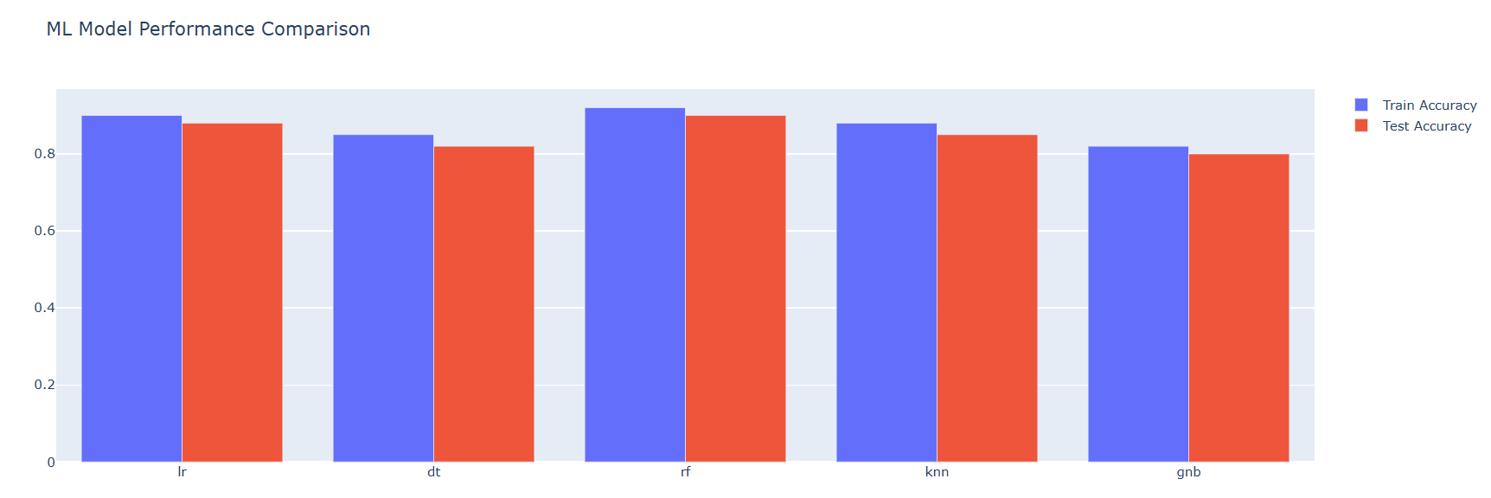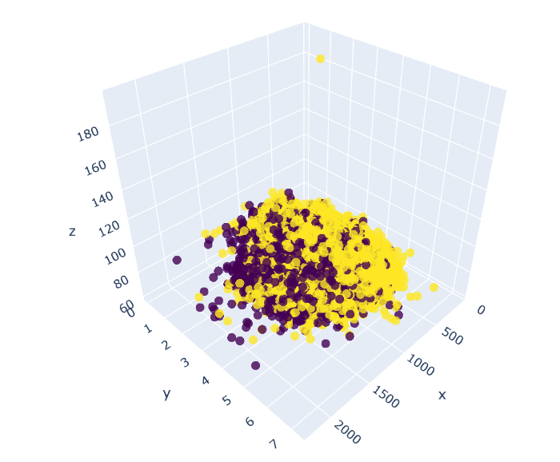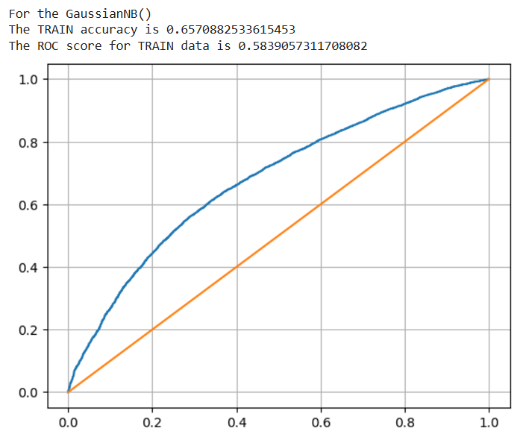

Fig-15.1 3D Heatmap

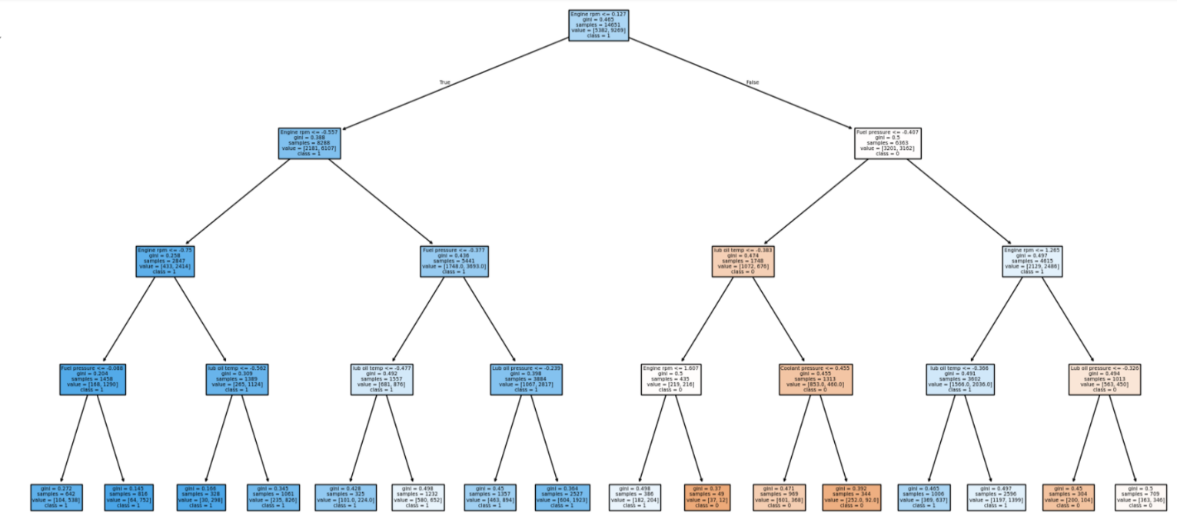

Fig-16.1 Train & Test Comparision

Fig-17.1 Decision Tree

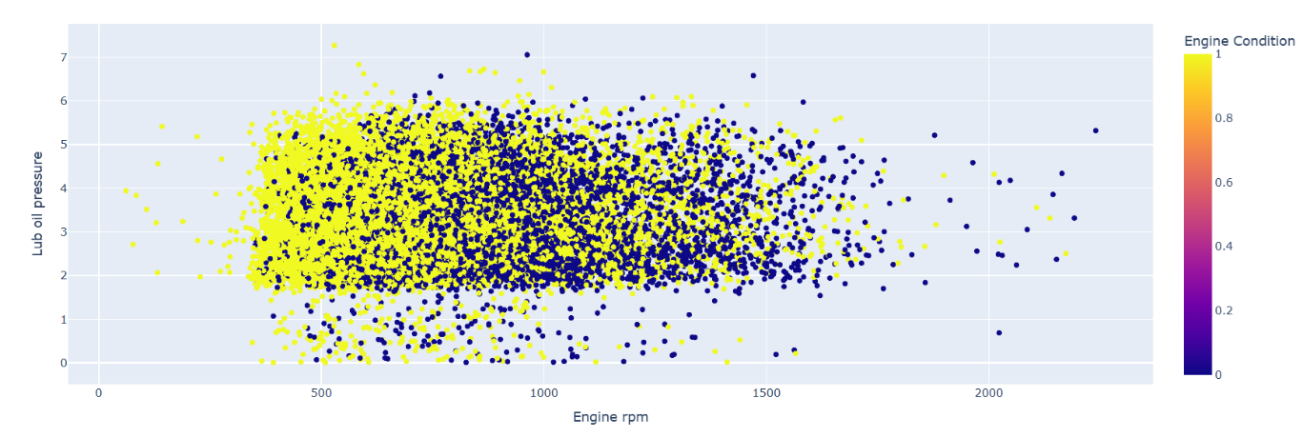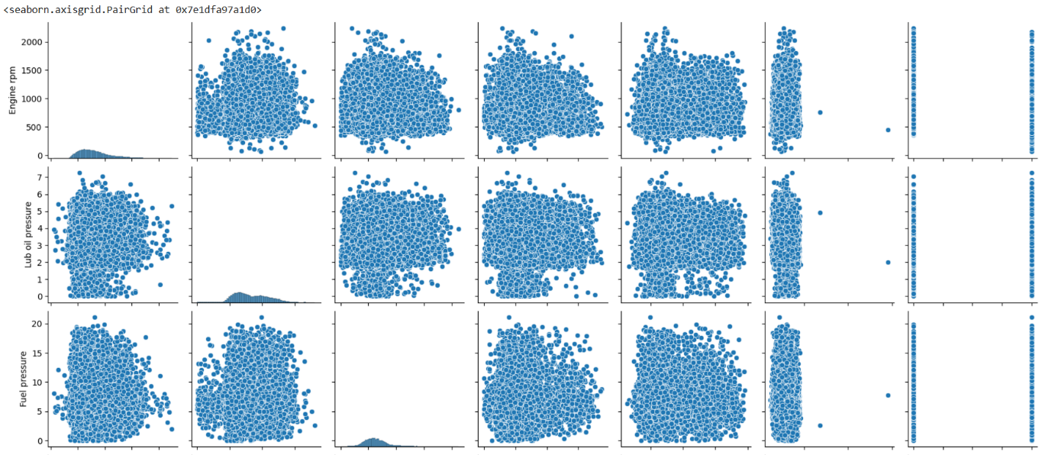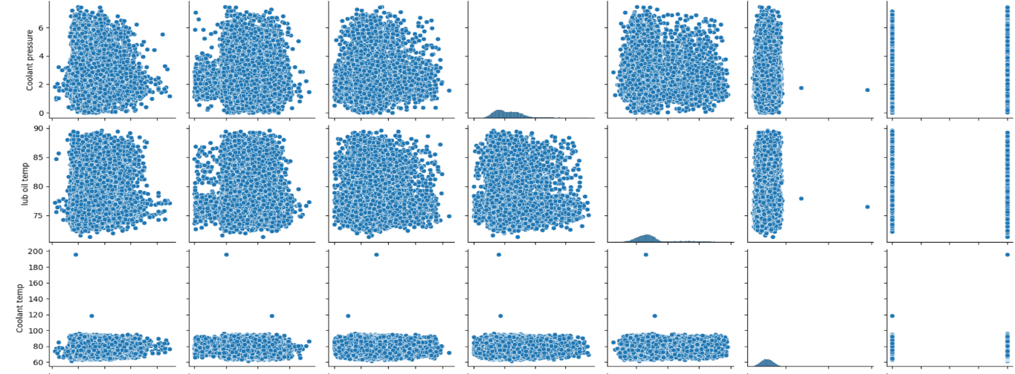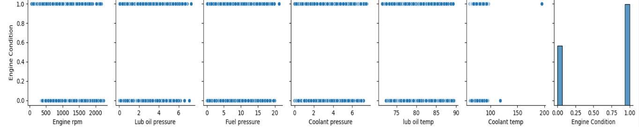

Fig-18.1 Dot plot Map

Fig-19.1 Grid Map

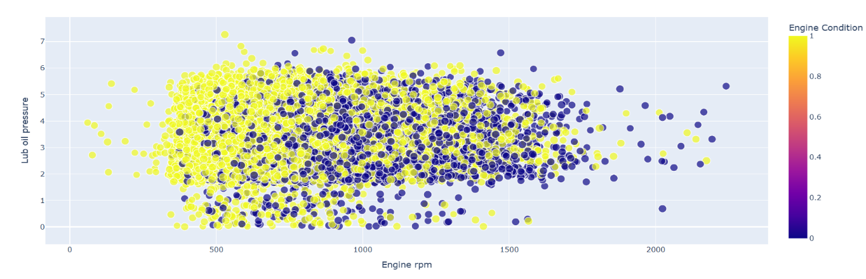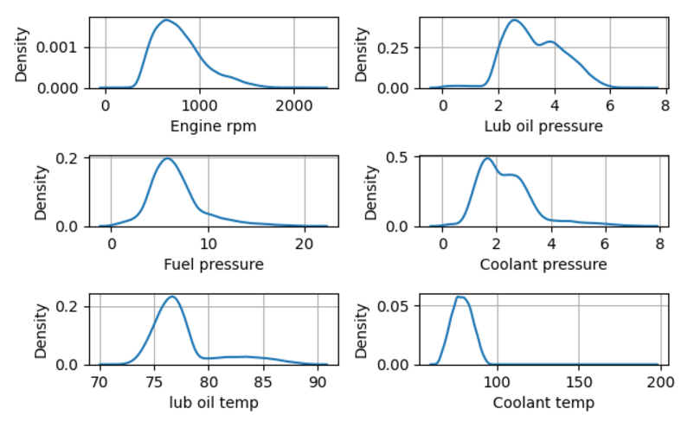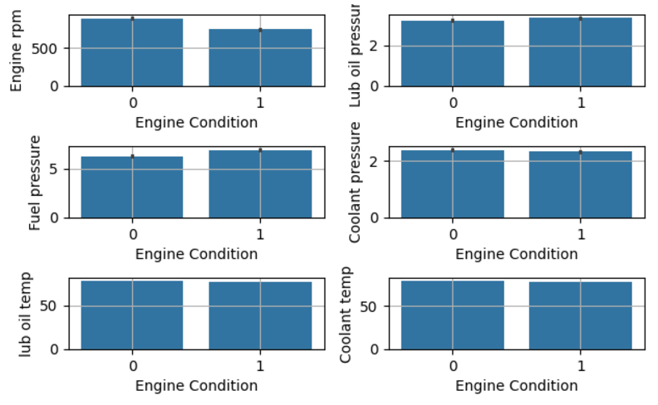

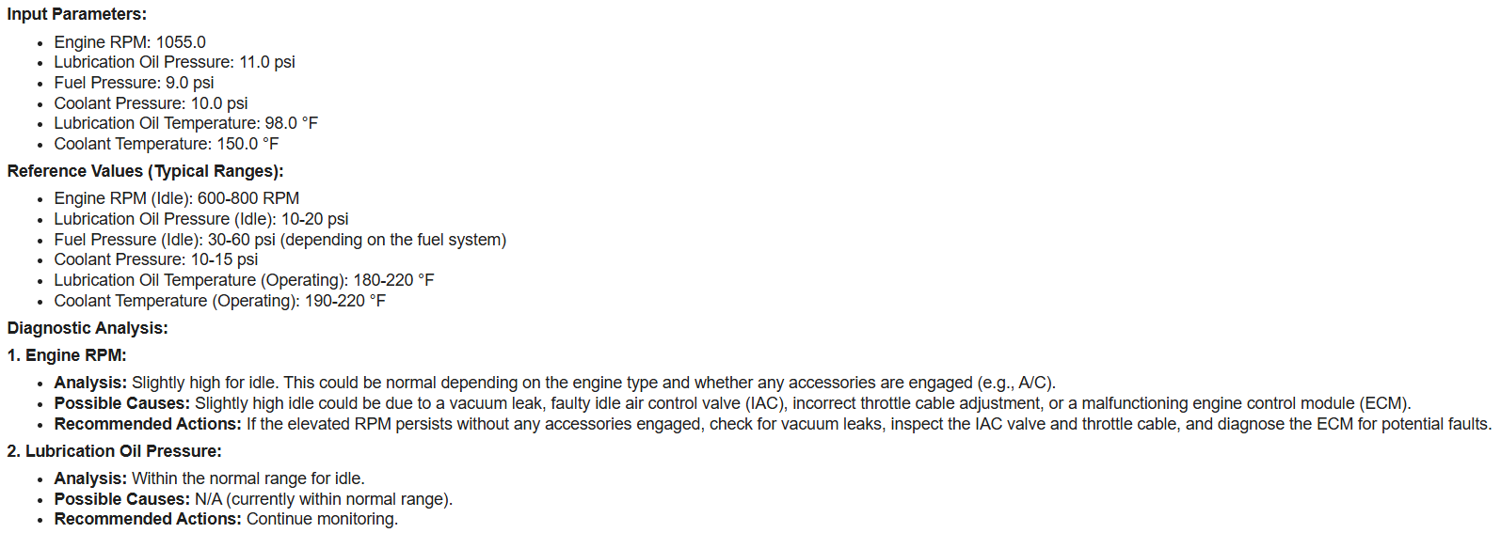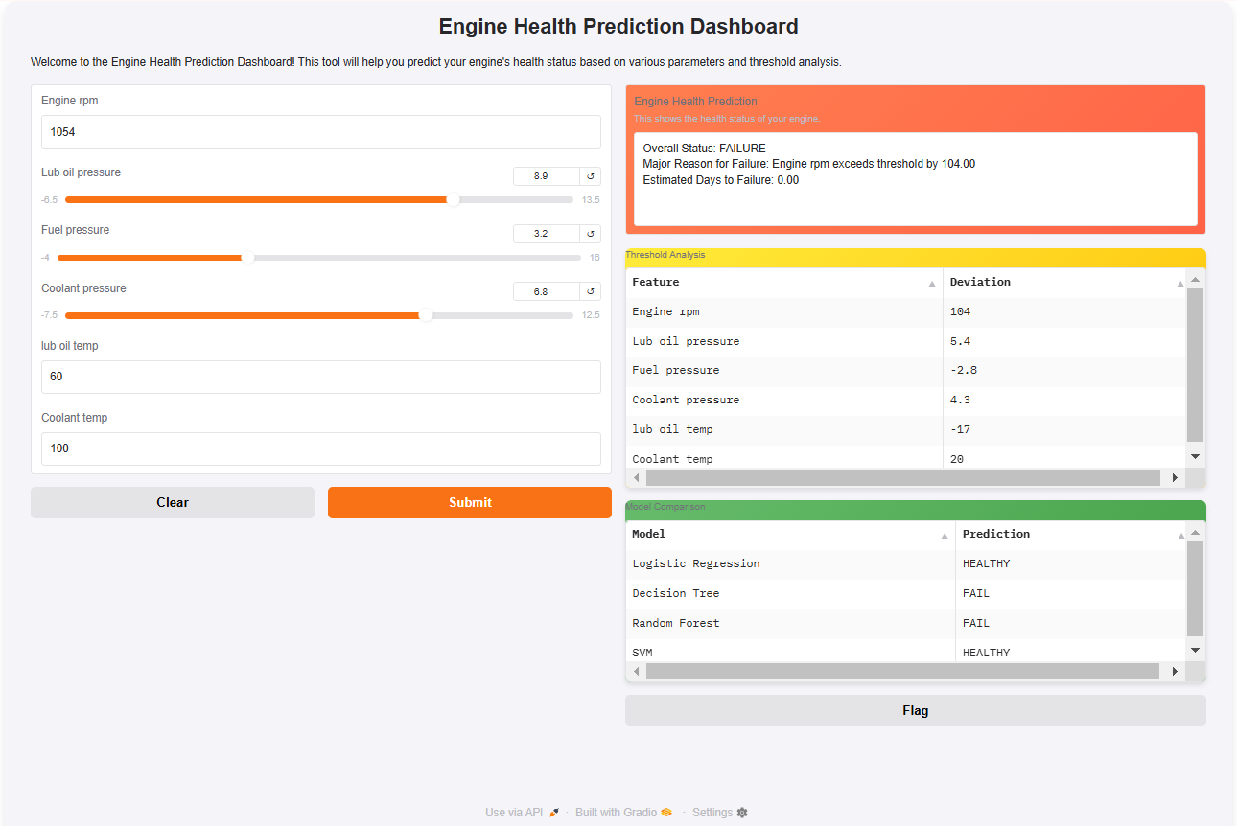

Fig-20.1 Web DashBoard

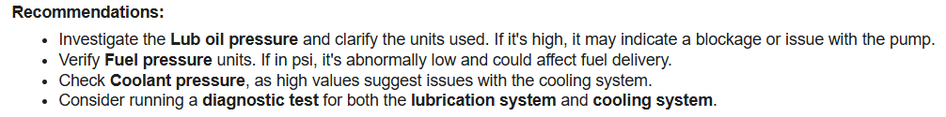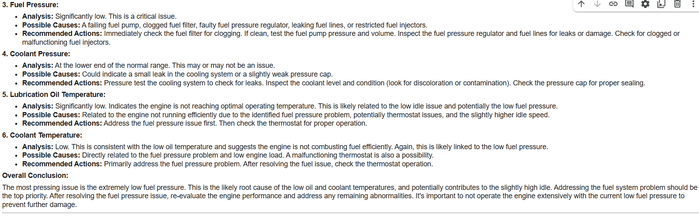

Fig-21.1 AI Analysis Report

**APPENDIX-C**

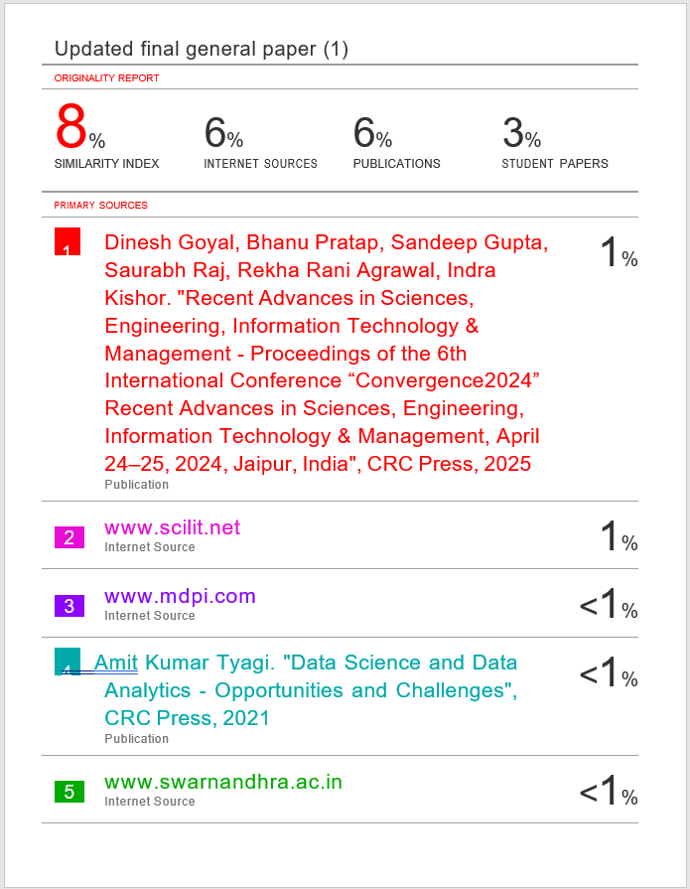**ENCLOSURES**



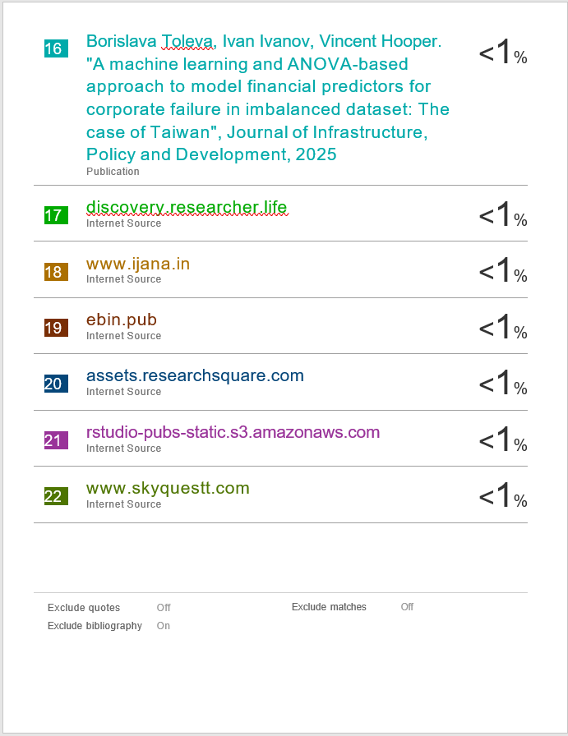

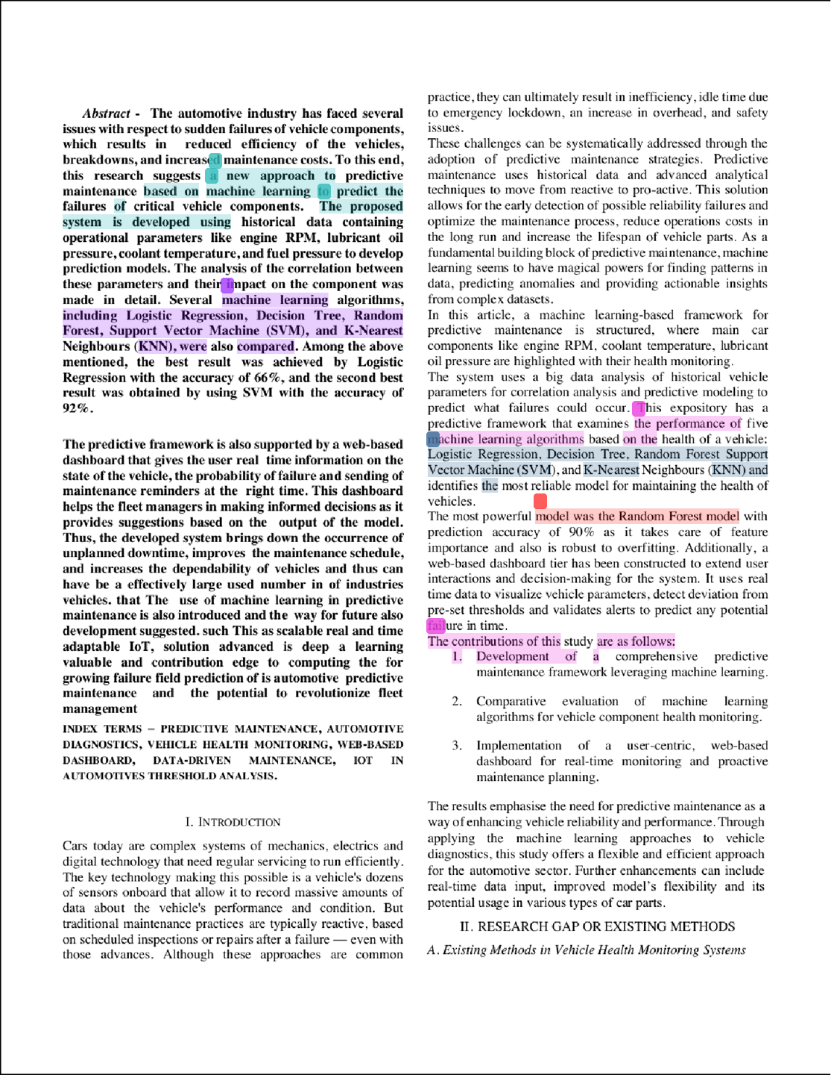

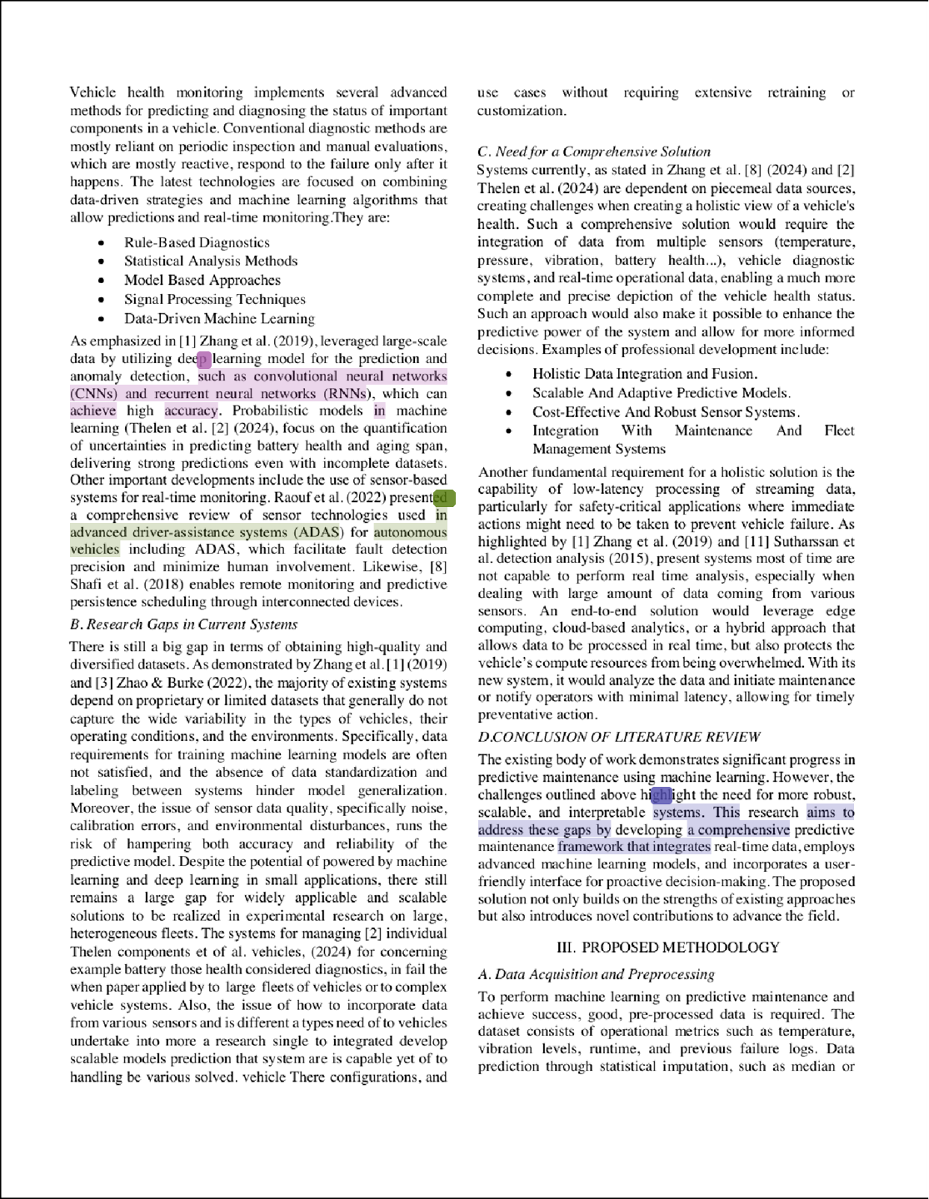

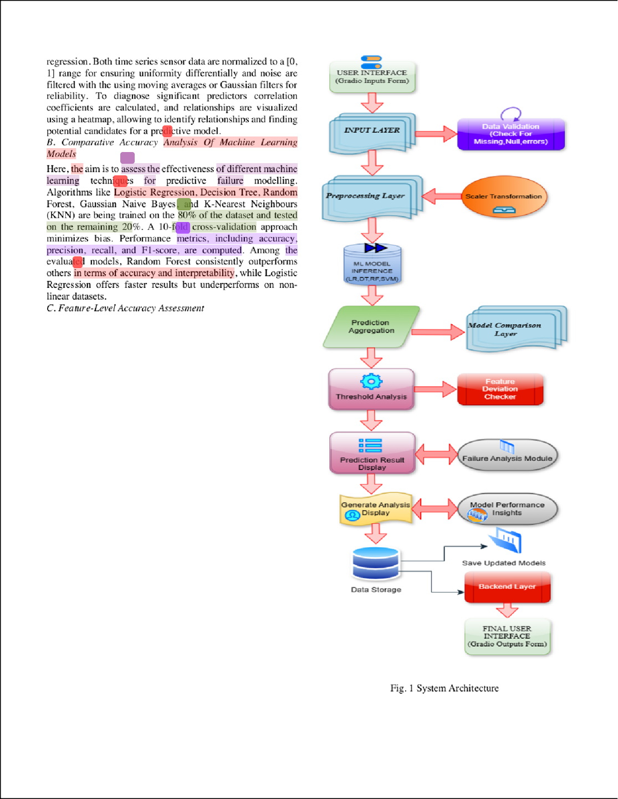

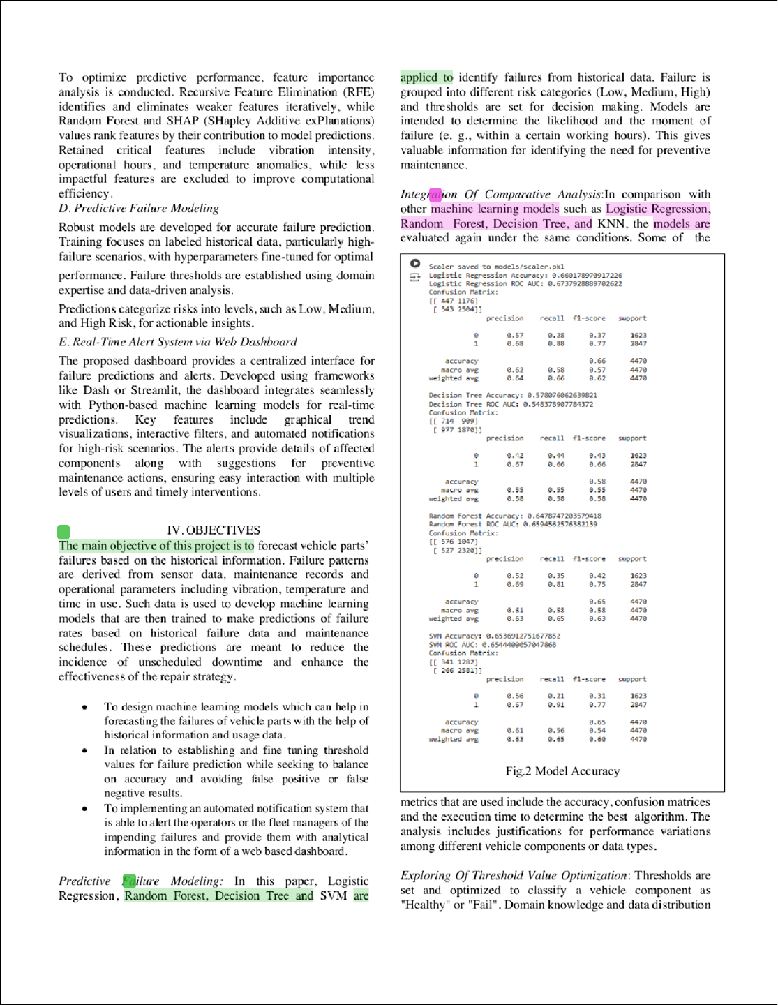

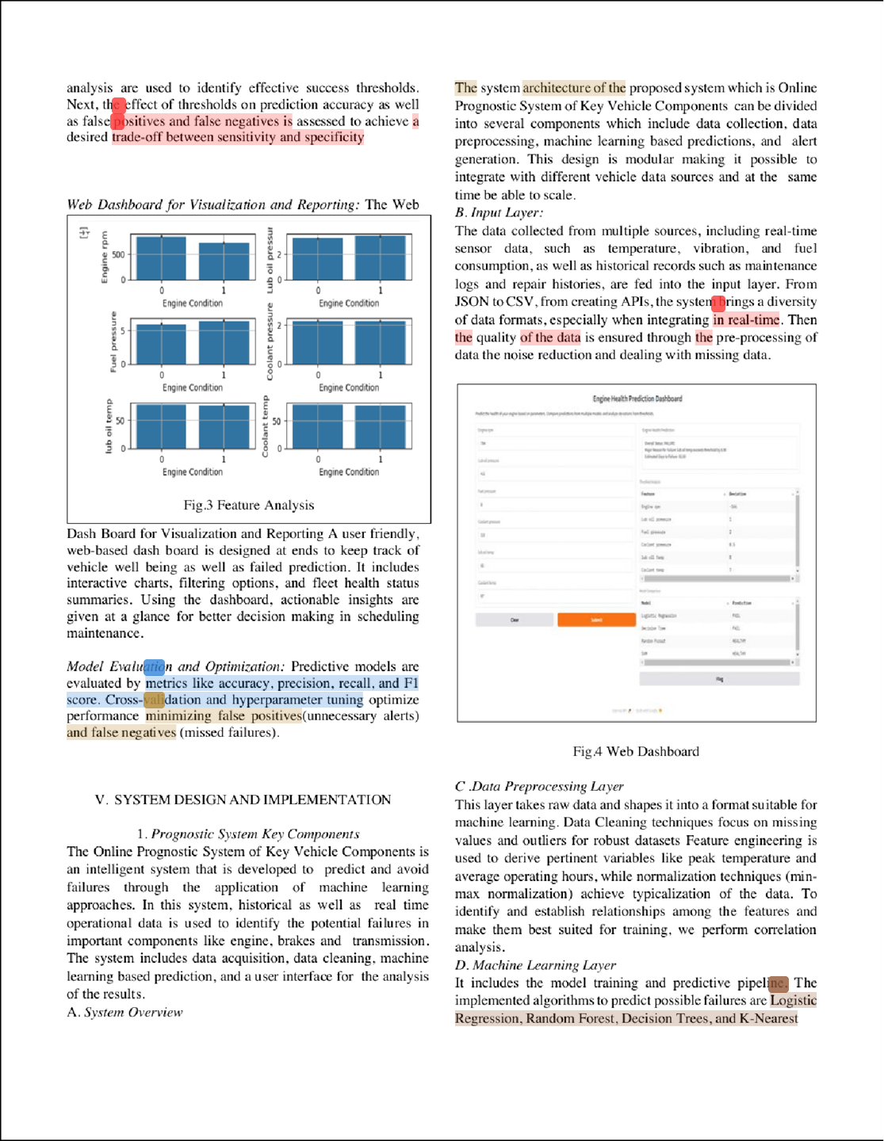

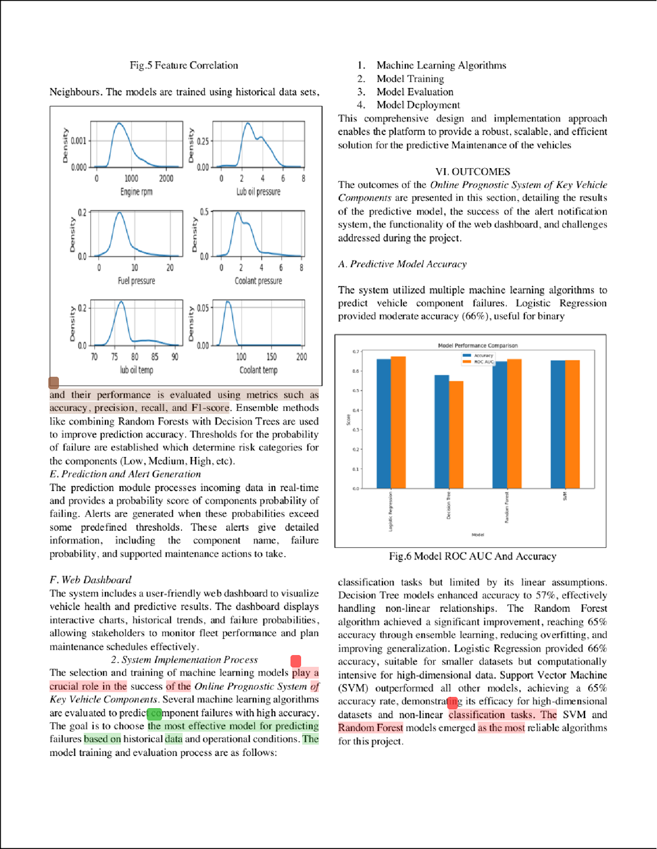

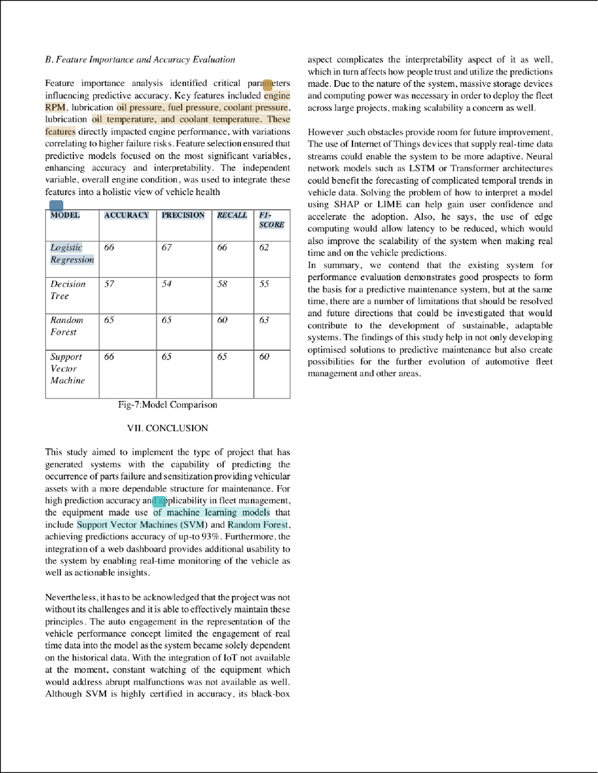





For the project, an Online Prognostic System for Key Vehicle Components, the most relevant Sustainable Development Goals (SDGs) are:

1. **SDG 9: Industry, Innovation, and Infrastructure**

Reason:

* Our project fosters innovation in vehicle maintenance by utilizing predictive analytics and real-time monitoring, which shifts the paradigm from reactive maintenance to a more efficient predictive approach.
* This enhances the reliability and sustainability of infrastructure by reducing vehicle breakdowns, thereby supporting smoother operations in logistics and public transportation systems.

1. **SDG 11: Sustainable Cities and Communities**

Reason:

* The project directly contributes to creating safer and more reliable transportation systems, which is critical for urban sustainability.
* Reducing unexpected vehicle failures leads to less traffic congestion, fewer accidents, and improved urban mobility, creating resilient transportation infrastructure for cities.

1. **SDG 13: Climate Action**

Reason:

* Your project addresses the global challenge of climate change by ensuring vehicles operate efficiently, thereby reducing fuel wastage and greenhouse gas emissions caused by faulty components.
* By identifying potential failures early, the system enables timely maintenance, which extends the lifespan of vehicle components and reduces the need for resource-intensive replacements.